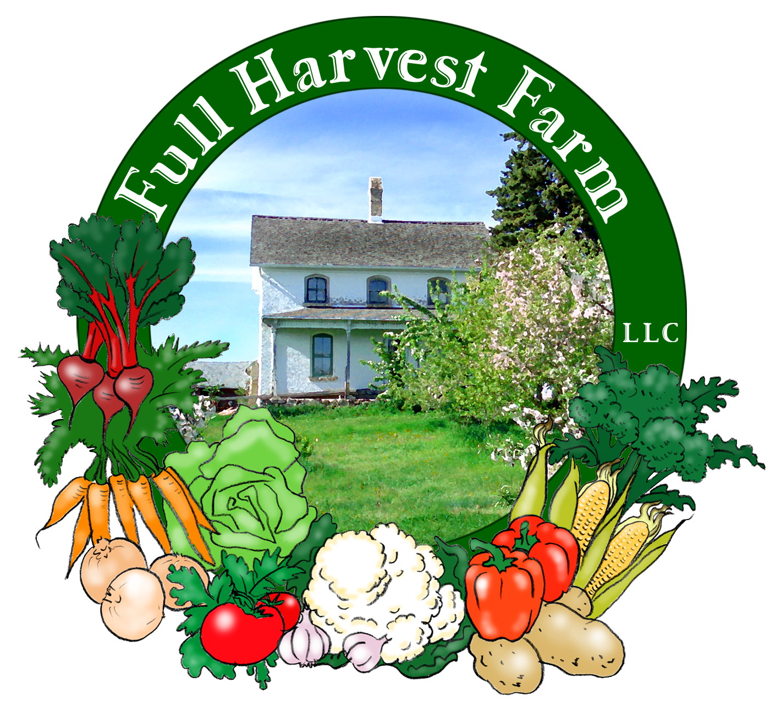
Full Harvest Farm, LLC
7112 County Road S
Hartford, WI 53027
262 673-6760
fullharvestfarm@gmail.com
http://www.fullharvestfarm.com
Box #18
Even Box -- LAST
30 October 2024
Contents
Brussels Sprouts
Carrots: Orange & Yellow
Garlic
Kohlrabi
Lettuce:
Napa Cabbage
Onions
Peppers: Green Bell
Potatoes: Red
Tomatoes: Cherry, Juliets, Slicers

New Stuff: Brussels sprouts, Napa cabbage
Choice Box: peppers, tomatoes, etc.

Brussels sprouts are one of those fall vegetables that taste better after they’ve been thru several frosts. These have been thru several cold snaps, but no real frosts--yet. Brussels sprouts also require a long time to mature, so we plant them by mid-May at the latest. They are grown mainly for the edible buds, or "sprouts", but the leaves are good too. You may notice that the sprouts grow up the stalk in a spiral pattern. Most of the sprouts will be firm, but sprouts at the top and bottom of the stalk may be loosely formed. Nothing wrong with that, they're still edible and taste great.
Brussels sprouts (Brassica oleracea) are part of the cabbage family and native to the Mediterranean. They first appeared in northern Europe in the 5th century. European farmers cultivated them around the 13th century, and they became very popular in the Netherlands and Belgium, especially around Brussels, hence the name.
Brussels sprouts are high in vegetable proteins, carbohydrates, vitamins A, B₆, C and K, dietary fiber and minerals. Their flavor and nutritional value are best when used soon after harvest.
To store, cut or snap the sprouts from the stalk and place them in a plastic bag. They will keep for a week or longer in the crisper drawer in your fridge. Don't worry if any sprouts are loose--they still taste good, there just wasn't sufficient time and moisture for all of them to mature fully.
Before cooking Brussels sprouts, trim the bottom, then peel off and discard any yellowed or damaged outside leaves. You can cook them whole or halved (my preference). Despite some claims, they do not cook faster if you cut an X in the bottom—a waste of your valuable time. Because of their stronger flavor, I prefer Brussels sprouts cooked until they’re tender all the way thru, but still retain a light green color. I use 2-3 tablespoons of butter, some salt and pepper, a skillet on low heat, covered. Stir them a few times, let the edges brown to caramelize their sugars, and cook them 10-15 minutes or so, until just soft. Or, try them roasted, just like beets. Brussels sprouts are also good in soups, stews and pot roast.
Because the tops of these Brussels sprouts were in relatively good shape, we've left them intact. Brussels sprout tops are another adventure into delicious greens. Several frosts have sweetened them up, and the top of the stalk is very tender and sweet also. Wash the leaves, discard the leaf stems, and steam them (easiest) along with the top of the stalk.

Napa cabbage is also called "Chinese" cabbage. It originated near Beijing before the 15th century, and is widely used in Asian cuisine. It's mild, sweet flavor tastes wonderful in a stir fry and works beautifully in the "Cabbage with Shrimp" recipe I gave you earlier this year.
The head of Napa is large, so you'll likely have enough to try it in a few recipes.
Asian cooks do a multitude of wonderful things with cabbage. Here is one recipe, adapted from Yamuna Devi’s “Lord Krishna’s Cuisine: The Art of Indian Vegetarian Cooking”.
Cabbage with Green Peas
Serves 6 to 8
In a heavy, 10” cast iron skillet, over medium-high heat, put:
4 Tbsp. butter or ghee
-When the butter is melted and starts to sizzle,
add: ¼ tsp. caraway seeds
½ tsp. coriander seeds
1 tsp. cardamom seeds
½ tsp. turmeric, ground
½ tsp. paprika
1/8 tsp. ground cloves
1/8 tsp. cayenne pepper (optional)
-Stir and cook the spices for 30-60 seconds only. Burned spices will taste bitter.
Add: 1 12 oz. can peeled & chopped tomatoes (1 ½ cups)
-Cook, stirring often, until the mixture is reduced to a thick sauce.
While the tomato mixture is cooking, chop:
1 lb. cabbage, cored, cut into quarters and sliced thinly
(No need to core Napa cabbage, just cut it in half, place cut side down, and slice.)
If you have more than 1 lb., put it into a plastic bag and store it in your refrigerator, unchopped.
Now add the cabbage, stir it in thoroughly, turn the heat to low, cover, and cook 10-15 minutes, stirring occasionally.
Add: 1 cup frozen peas
-Stir, cover and cook 2-3 minutes, or until the peas are just hot.
Add: 2 Tbsp., fresh cilantro or dill, chopped
freshly-ground pepper
salt to taste
Stir to mix, and serve.
You can also use Napa cabbage in that lovely Cabbage with Shrimp recipe.

Here's the perfect recipe to use up an abundance of sweet peppers, altho there's no reason you can't mix in some spicy ones.
Peperonata
In a large pot over medium heat put:
3 Tbsp. olive oil
2 onions, chopped
3 cloves garlic, chopped
-sauté until soft and lightly browned, stirring often, about 5 minutes.
Add: 4 potatoes, chopped
5 tomatoes, chopped (about 3 cups)
4-6 sweet peppers, cut into ½" chunks
-using different-colored peppers makes the stew very pretty.
1 cup stock, if needed
1/3 cup capers, drained
¼ cup fresh basil, chopped, or 2 tsp. dried
salt and freshly-ground black pepper
Simmer until the potatoes are soft. Stir occasionally. Taste, and adjust seasoning as necessary.
Notes: You can eat this as a stew. Omit the potatoes, and you have a delicious sauce for pasta.

Field Notes
Most of our produce has been harvested, but some still remain in the fields: Napa cabbage, lettuce, Brussels sprouts, broccoli, cauliflower, kohlrabi, broccolini, a little chard, beets, perhaps some radishes. Hmmm, that sounds like quite a bit, doesn't it?
The hope is that, if the warmth and light freezes continue for a few more weeks, these things will continue to grow and can be sold to our wholesale customers.
That would be nice.
It's been an interesting year: lots of rain in the beginning, almost no rain and warm temperatures at the end. At this point, drip tape is still getting a workout.
We have many successes to look back on for the 2024 season: lettuce, beets, potatoes, onions, garlic, herbs, kohlrabi, fennel.
Not quite so successful were: cauliflower, winter squash, Brussels sprouts, carrots. Well, we have plans to fix that next year.

After careful consideration, Chuck and I have decided to shrink our organic vegetable business further. So next year, we will not offer a CSA program. We know that many of you love your weekly boxes of produce, and it has been our pleasure to be your farmer. As we grow older, we find ourselves having less energy and needing more time to rest. At 65 and 70, it's time to slow down.
In 2025, we will still offer a Worker Share program where folks will help on the farm earning $10/hour as credits they use towards purchasing vegetables. We're working with our current Worker Shares to flesh out the details, and will post those in the coming months on our website.
Our focus in 2025 will be the West Bend Farmer's Market and a few wholesale clients.

Chuck and I would love to be able to pass on our organic vegetable farm to another, younger farmer who has all the ambition and energy to carry on for many years. We're willing to rent our facility, land and equipment, to this person while we continue to enjoy our home on the farm. Please pass on this idea to anyone you happen to know who may be interested. Thank you!

Happy Halloween
and
Happy Holidays!
Terry & Chuck

