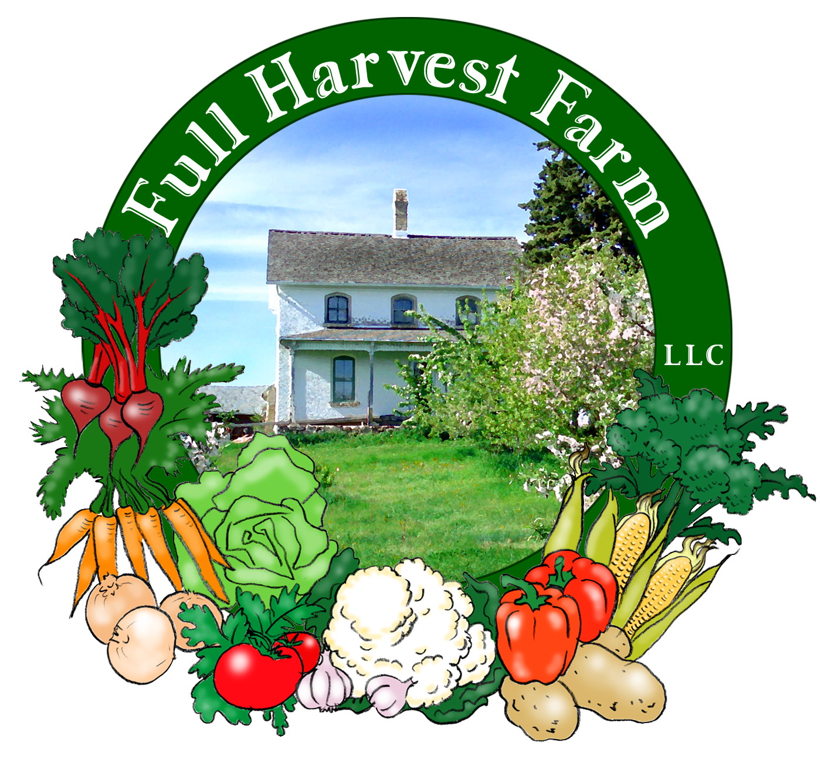
Full Harvest Farm, LLC
7112 County Road S
Hartford, WI 53027
262 673-6760
fullharvestfarm@gmail.com
http://www.fullharvestfarm.com
Box #17
Odd Box
23 October 2024
Contents
Broccolini
Carrots: Orange & Yellow
Garlic
Lettuce: Red Leaf
Onions: Yellow
Peppers: Green Bell, Red/Green Bell, Green Carmen
Potatoes: Red
Tomatoes: Juliets, Slicers
Winter Squash: Thelma Saunders Sweet Potato

New Stuff: winter squash
Choice Box: peppers, tomatoes, etc.

Winter squash contains far more vitamin A than summer squash, is an excellent source of potassium, high in fiber and complex carbohydrates.
Here are some hints for storage: check the skin before storing winter squash: if there are any holes, blemishes or soft spots, plan to use that squash soon and cut out the soft spots first, as the deterioration will only spread.
The best way to bake winter squash is to wash the outside, cut off the stem, then cut the squash in half. Set your oven at 400 degrees, line a half-sheet pan with aluminum foil to make cleanup easier, and place the squash on the foil, cut side down. Do not remove the seeds yet—they give the roasted squash more flavor. Bake for 30-60 minutes, or until the squash is soft when you poke it with your finger. Remove from the oven, flip over and scoop out the seeds using a large spoon. Drizzle with melted butter, add a little brown sugar, terrific.
Thelma Saunders Sweet Potato squash is the only winter squash we were able to grow to maturity this year. Winter squash needs a long time in the ground and does not tolerate frost, so you have to get it in the ground shortly after the last spring frost. Sadly, the ground was pretty wet around that time, and ours got in late. Neither our butternut, nor our kubocha squashes produced anything to speak of.
Acorn-type squashes do not store well, especially if they have any nicks or blemishes in their skin. Some of our Thelma Saunders are showing "sugar spots", small, slightly darker spots on the outside. Use these first.
The following recipe is a new favorite. I recommend using butternut squash for this one.
Cheesy Winter Squash Pasta
In a large pan or medium pot, put:
4 cups chicken or vegetable stock
1 ½ cups peeled and cubed butternut squash
-Bring to a boil, turn down to a simmer, and cook the squash until it is very soft. Puree with a hand blender.
Add: 1 medium onion, minced
3 garlic cloves, minced
¼ tsp. red pepper flakes, optional
¼ tsp. salt
¼ tsp. freshly ground pepper
1/8 tsp. nutmeg
1 lb. pasta, such as farfalle, penne,etc.
Put pan back on the stove, bring to a boil, stir to mix ingredients thoroughly, turn down to a simmer, and cook, covered, until pasta is al dente (check package directions for cooking times).
Now Add: 2 Tbsp. butter
4 oz. cream cheese, cubed
-Stir until cream cheese is melted. Add salt and pepper to taste.
Top with: chopped parsley, chives, etc.
NOTE: You can use any kind of winter squash to make this sauce: each will give it a different flavor. To save time, open a can of pumpkin puree (NOT pumpkin pie filling) and measure out 1 cup to replace the cubed, raw squash. Cooking the pasta in the sauce enables it to absorb the flavors of the sauce, making an even better dish. And, no grated cheese necessary.

It took some effort, but we were able to harvest some small, yellow carrots from the field. They are included with the orange.

In 2013, CSA member Jessica S. sent me this recipe: "Our Italian side of the family makes Punapun. But don't ask me how to spell it because I can't find it online! (Italian father-in-law says spell it "any way you want. Look up in Italian meaning dunk and dunk" but I can't find that.) This has been a great way to use our recent tomatoes, peppers, and onions!" Since you now have lots of these, the recipe seems appropriate.
Punapun (Italian salsa)
Juicy ripe tomatoes, at least 4, cut in chunks
1/2 onion, sliced
1 bell pepper, any color, sliced in chunks
fresh basil ~10 good sized leaves, cut or torn into pieces
Italian seasoning (if needed)
garlic salt
olive oil
salt & pepper
a bit of water if desired to make it juicier
Mix everything in bowl. Cover with lid and let it sit at least overnight in fridge so that flavors meld.
Serve with Italian bread. (Any good loaf will do.)
Tear off chunks of bread to dip in the punapun. Make soakies in the juice, and use the bread to pick up chunks of veggies.

Field Notes
The weather continues dry, which makes it easier to harvest outside, but doesn't nourish the plants much. This is the driest period I can remember in Fall, also the warmest. We're grateful to be able to work outside without long johns, hats and gloves.
Looks like a freeze Thursday morning, so stuff will be covered.
Altho the Brussels sprouts are sailing through freezes like the hardy brassicas they are, the sprouts are not growing as hoped. We believe we'll have enough for the last box, but the sprouts will be small, and there won't be many. If cabbage worms don't chew them up, we may have some Brussels sprout tops as well.

For our Every-Other-Week--ODD Week members, this is your last box. Thank you for joining us this season. Chuck and I hope you've enjoyed your produce.
For everyone else, one more box to go.

Chuck and I want to remind you that we will be at the West Bend Farmer's Market this Saturday, October 26. This is the last market of the season, and a great opportunity to stock up on fresh produce. Fall provides us vegetable farmers with the widest variety of crops to harvest, so the biggest choice for shoppers. And the West Bend Farmer's Market is the 2nd largest market in the state, 2nd only to Madison's Capitol Square market, so you should have lots to choose from.
We hope to see you there.
Terry & Chuck

