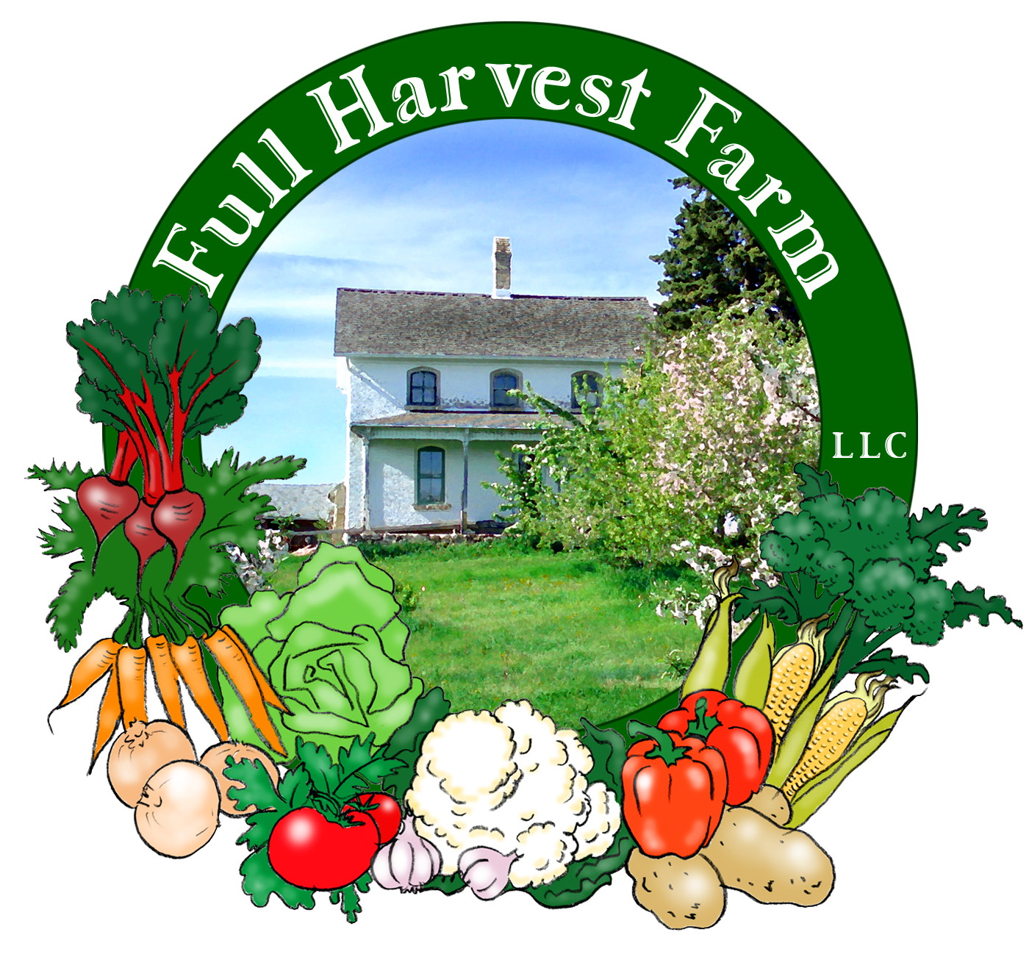
Full Harvest Farm, LLC
7112 County Road S
Hartford, WI 53027
262 673-6760
fullharvestfarm@gmail.com
http://www.fullharvestfarm.com
Box #16
Even Box
16 October 2024
Contents
Parsley
Broccolini
Carrots
Garlic
Leeks
Lettuce: Mixed
Peppers: Green & Red Carmens, FlavorBurst
Tomatillos
Tomatoes: Slicers

New Stuff: broccolini
Choice Box: peppers, tomatoes, ??

I'm going to spend a little time explaining broccolini because it's so different from broccoli raab.
Firstly, broccolini tastes sweeter than broccoli raab. As a tasty green, it went to the top of my list. Secondly, it looks very different: large, smooth, dark green leaves, white flowers instead of yellow. If you get any flowers in your bunch, lucky you! They are quite sweet so snack on those first. Broccolini will form a small cluster of large buds before these open to flowers, like broccoli raab.
Like broccoli raab, it's the leaves, upper stalk and flowers that are the edible focus here.
Nutritionally, broccolini is high in vitamins A and C, calcium, iron, fiber and contains no fat.
To prepare broccolini, pull off the leaves from the stalk and cut off the stem. Wash the leaves, pile the large ones up and slice them in half down the center vein to make them easier to eat. Stack one half on top of the other and cut crosswise. Smaller leaves can simply be cut crosswise. You will likely have some holes in several of the leaves--a bit of insect damage only, with no effect on the taste. Much of the stalk is tender and delicious. Let your knife tell you where the fibrous part stops and the tender part starts. I cut that into rounds--very sweet. Terry's Favorite Way To Cook Any Vegetable works great here (butter-salt-pepper).

The freezes this week mean it's time to pick the entire pepper patch. Those darn FlavorBurst peppers didn't produce many mature ones, but you're getting what we have. This blocky pepper starts out light green and will have a green pepper flavor without the bite. If you get one that's turning yellow/yellow-orange, you've got a more mature fruit with better flavor.
The Carmens did better, so there are more red or partially red ones this week as well as green. Now you can compare the 2 for flavor.
Because you're getting so many peppers in these last 2 or 3 boxes, I want to tell you an easy way to freeze them. Wash them first, cut out the core, ribs and any bad spots (I get a lot of these types in my kitchen), cut them in half, put on a sheet pan and pop them in the freezer. Once frozen, drop the halves into a ziplock freezer bag and put back into the freezer. When you need peppers to cook with, pull out however many pieces you need. If you just have a couple of peppers, prepare as above but forget the sheet pan and just pop them anywhere in the freezer. Once frozen, drop them into that freezer bag with the rest of the peppers.

These will be the last tomatillos of the season.
Our Worker Share Peggy recommended this recipe from Panning The Globe:
Chicken Enchiladas Verdes
For The Salsa Verde:
2 pounds tomatillos, husked and rinsed
1 medium white onion, peeled and cut into 8 wedges
2-3 jalapeño peppers, stem end cut off. If you don't like a lot of heat, slice them in half lengthwise, and remove the seeds and white pith
1 tablespoon olive oil
1 cup roughly chopped cilantro leaves and tender stems (remove thick stems), plus more cilantro leaves for garnishing
I tablespoon finely chopped garlic (2-3 large cloves)
½ teaspoon kosher salt
To make the salsa verde, preheat oven/griller on high. Place oven rack 6"/15cm from the heat source. In a large bowl toss tomatillos, onion and jalapeños with 1 tablespoon olive oil. Lay them out on a rimmed baking sheet and broil/grill for 7 minutes or until there are some brown, charred spots on the tomatillos. Lower temp to 400F. Turn the tomatillos over with tongs. Cook for another 7 minutes, to soften. Cool on the baking sheet for 10 minutes or so, then put roasted vegetables and any accumulated juices into the bowl of a food processor. Add cilantro, garlic and salt. Pulse several times until you get your preferred consistency. You should have about 4 cups of salsa.
If you don't have 2 lbs. of tomatillos, cut the recipe in half. This will still give you enough salsa verde to spread on the bottom of the baking dish and mix with the chicken. You can use a jar of other salsa to cover the top of the enchiladas, or simply used chopped tomatoes.
For The Enchiladas:
12 6-inch soft corn tortillas
3 ½ cups shredded cooked chicken, about 1 ¾ pounds.
2 tablespoon sour cream, plus more for garnishing
4 ounces Cotija cheese, grated
6 ounces grated cheddar or jack cheese
Toppings:
½ small red onion, very thinly sliced
chopped cilantro
sour cream
Set oven to 350F. Spread 1 cup of salsa verde into the bottom of a large rectangular casserole or baking dish. In a large bowl combine shredded chicken with 1 cup of salsa verde, 2 tablespoons of sour cream, and 4 ounces Cotija cheese.
Roll the Enchiladas: Put ¼ cup of the chicken mixture on one end of a tortilla, roll it up tight and place it seam-side down in the baking dish. Repeat with all of the tortillas. Spoon a cup of salsa over the tops of the enchiladas, using the back of a spoon to spread the salsa over all exposed surfaces. Sprinkle grated cheddar cheese on top. Bake for 15 to 20 minutes, until cheese is melted and enchiladas are heated through.
Serve with sour cream, red onion, cilantro leaves and remaining salsa.

Field Notes
Sunday afternoon was rainy with off and on showers much of the afternoon. This helped the ground soften up somewhat for digging carrots and harvesting leeks. Monday afternoon also brought us some rain--and hail! That was a surprise.
Wednesday and Thursday mornings will give us our first freezes. Chuck has pulled all the stakes out of the tomatoes so we can lay those vines on the ground in hopes of extending the season past this freeze. The extended forecast does not predict another freeze through the 29th. Interesting . . .
We were happy to see the Thelma Sanders Sweet Potato squash produce enough for the last 2 boxes. Sadly, none of the other winter squash gave us much fruit to speak of.
Brussels sprouts are still small, but they're there, so we're planning to include Brussels sprout stalks in the last 2 boxes if the sprouts grow big enough. Cross your fingers.
We have quite the patch of Napa cabbage, plenty to put them in the last 2 boxes. Great in stir frys, raw in salads, or you can use it for the Cabbage with Shrimp recipe in Newsletter #8.

Please bring your wax boxes back to the farm so we can reuse them. Thank you!

Looking forward to the daytime warmup.
Cheers,
Terry & Chuck

