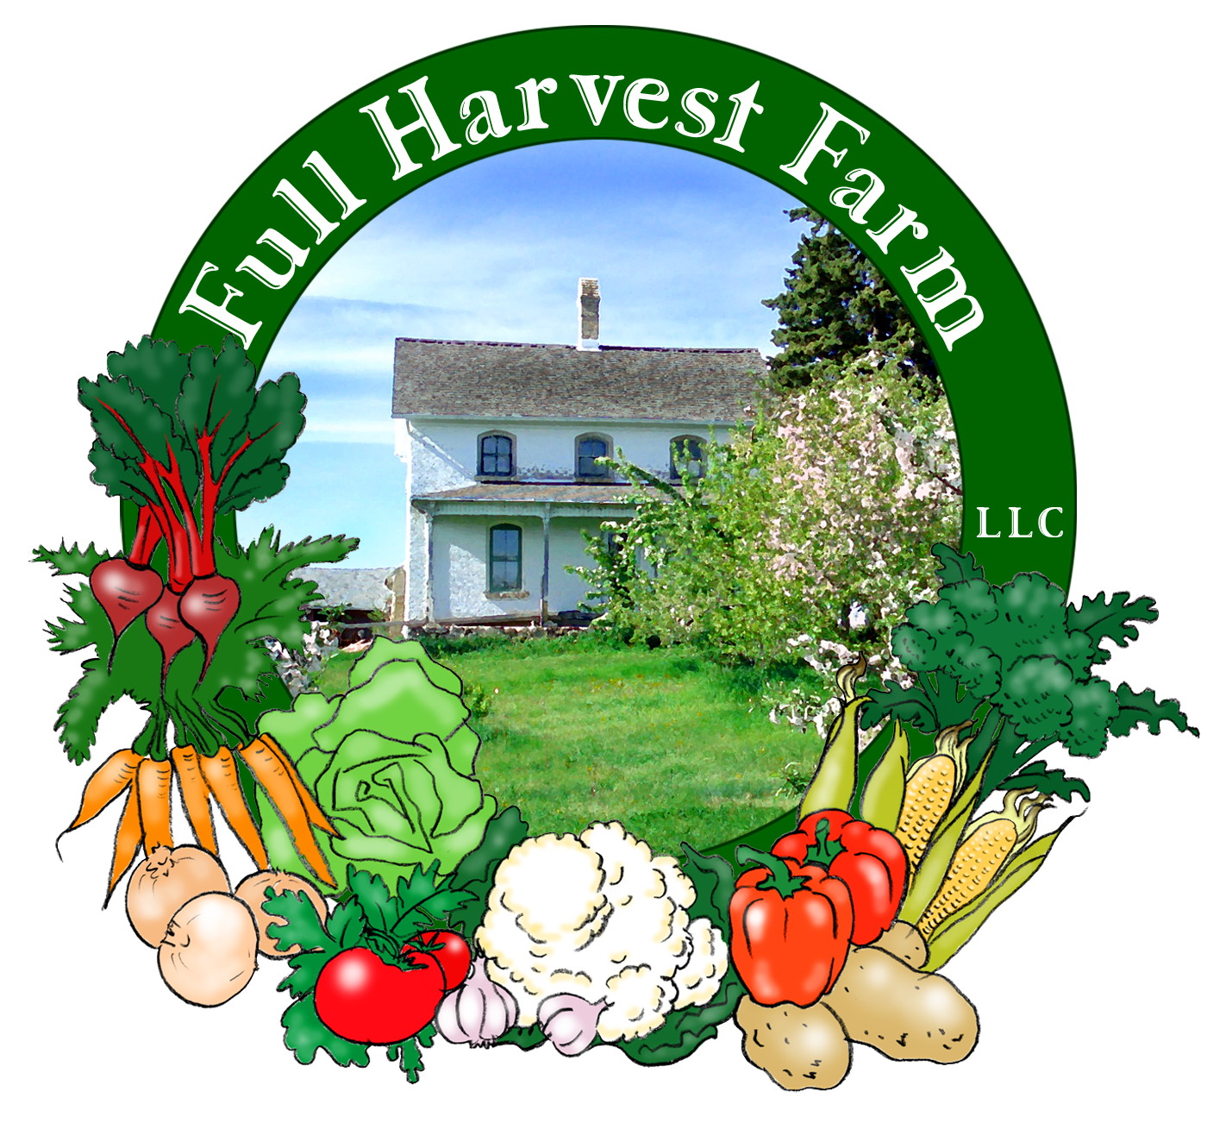
Full Harvest Farm, LLC
7112 County Road S
Hartford, WI 53027
262 673-6760
fullharvestfarm@gmail.com
http://www.fullharvestfarm.com
Box #15
Odd Box
9 October 2024
Contents
Bok Choi
Broccoli
Carrots
Garlic
Leeks
Peppers: Carmen, Red Bell
Radishes--Family Shares Only
Tomatillos
Tomatoes: Juliets, Orange Cherry, Slicers
White Turnips--Couple Shares Only

New Stuff: leeks, tomatillos
Choice Box: peppers, tomatoes, ??

Leeks are one of the best-tasting alliums around. Their flavor is sweet, mild, yet complex and delicious. Adding them to a dish improves the flavor. As leeks grow, most farmers pile soil around the stalk to keep it white: sunlight causes photosynthesis, which turns the stalk green. We did not pile dirt around these, so more of the stalk will be green. It’s still tasty, tender and very usable, but the white portion is sweeter. To clean leeks, chop off the floppy leaves and the root end, slice it down the middle and rinse under running water, getting between the layers as much as possible. If soil is mounded around the stalk, it tends to sift down between the leaves. Leeks cook faster than onions because the sections are thinner, so watch them carefully and use a lower heat. The floppy leaves are tough, but make an excellent addition to stock--store them in your freezer until needed. The very upper part of the green stalk will be tough also: let your knife tell you when it’s time to stop cutting.
Store leeks, unwashed, in a closed plastic bag in your vegetable drawer so their onion flavor doesn’t travel to the other vegetables. They should keep 2 weeks or a bit longer.
Potato Leek Soup Serves 4
In a pot or large saucepan over low heat, melt:
4 Tbsp. butter
Add: ½ lb. leeks, washed and chopped
¾ lb. potatoes, peeled and thinly sliced
-Cover and cook about 8 minutes.
Add: 4 cups chicken stock
1 bay leaf
1 Tbsp. chopped parsley stems (yes, stems)
½ tsp. freshly ground pepper
½ tsp. dried thyme
-Bring to a boil, lower heat to a simmer and cook until the potatoes are fork-tender, 20-30 minutes.
Remove pot from heat, fish out the bay leaf, and puree. A hand blender is the easiest tool for this task, but a blender or food processor works as well. If you use a blender or food processor, be careful to cover the container so you avoid being splashed by hot liquid.
Return puree to pot and add:
1 cup heavy cream
-Bring to a simmer (heavy cream will not curdle when boiled). Serve with a sprinkling of chives, scallions, chopped cilantro or parsley.
If you prefer a chunky soup, simply dice up the potatoes, cook until they are tender, add the cream, heat to a simmer and serve. You can substitute milk for cream, but heat the soup only to steaming—simmering will curdle the milk.

Tomatillo means “little tomato”. It is shaped like a small, green tomato enclosed in a papery husk. The fruit starts out small and is completely hidden by the thin, green husk. As it grows, the fruit fills the husk and eventually splits it open. Tomatillos are a member of the nightshade family (solanaceae), as are tomatoes and potatoes. It's Latin name is physalis philadelphica. Another physalis member is the ground cherry, smaller, sweeter, and often used to make jams and pies.
Tomatillos are a very good source of vitamins C, K, niacin, potassium, manganese and dietary fiber, and a good source of iron, magnesium, phosphorus and copper.
To store tomatillos, pull off the papery husk, wash off any dirt and the sticky residue from the husk under warm water (I roll 3-4 around inside my cupped hands so they bump against each other). Then, drain them briefly and put inside a sealable plastic bag. They’ll keep 2 weeks in your vegetable drawer, and still taste good. You can use them raw in salads, put them in stir frys, or in any number of Mexican dishes, like salsa verde or enchiladas.
The cultivar we’re growing matures thru green to light green then light yellow, getting sweeter as it gets older. Most Mexican cooks prefer to use tomatillos when they’re green, as they believe tomatillos have the best tart-sweet contrast at this stage.
Our tomatillo patch is loaded with fruit and we can now put them in your box.
Here's my very own raw salsa verde recipe. I think it's pretty darn delicious:
Raw Salsa Verde Makes about 2 cups
In a blender or food processor, put:
1 lb. tomatillos, husks removed, washed and cut into quarters
1 tsp. chopped garlic (or more as you wish)
1 shallot or small onion, coarsely chopped
1/3 cup cilantro, roughly chopped, loosely packed
½ tsp. ground cumin
½ cup Anaheim or Italian pepper, roughly chopped, or 1-2 Tbsp. Jalapeño
salt & freshly ground pepper
Process until the ingredients reach a fine consistency. Serve with corn chips, in tacos, etc.
And here's a more traditional recipe:
Roasted Salsa Verde
Makes about 2 cups
Turn on your broiler, or set your oven as high as it will go. Line a half sheet or jellyroll pan with aluminum foil.
Put on the pan in a single layer:
1 lb. tomatillos, husks removed, washed and cut in half
1 Jalapeño, washed, halved, stem, seeds and/or ribs removed
1 small onion, cleaned and quartered
2 lg. garlic cloves, UNpeeled
-Roast until the contents are slightly charred, 5-15 minutes or more, depending on the temperature of your oven. When done, remove from oven and let cool 15 minutes on a rack.
Put into a food processor or blender:
contents of pan—but peel the roasted garlic first
1 Tbsp. lime juice (fresh if you have it)
1/3 cup fresh cilantro, loosely packed
salt and freshly ground pepper to taste
Process until you’ve reached the consistency you desire: less for a chunky salsa, more for a smooth one. Taste and adjust the seasonings.

The current broccoli patch is producing strongly right now, but is almost picked out. This is likely the last time you'll get broccoli.

Carrots are back! Our goal is to give you carrots in the last 4 boxes since they keep in the refrigerator for a month or longer. We'll see what the carrot patch yields.

And it's time to load you up with garlic for the long winter ahead. Check the nooks and crannies of your box for those bulbs. They'll be in all 4 boxes.

The sweet, Carmen peppers are finally turning red. This is the best-tasting pepper we grow, so I'm glad they're finally maturing. If we get another week or so of warm-enough weather, you may get them in these last 4 boxes. Otherwise, green Carmens. We were able to find mature, red bell peppers too, so a bit of color to go with those tomatoes.

We are a bit overrun with radishes, so the Family Shares are getting those. Chuck and I wanted the EOW--Odd Shares to get white salad turnips at least once, so the Couple Shares have salad turnips.

Field Notes
Monday morning was frosty, so our goal Sunday evening was to cover everything that might be damaged by that frost and the possible ones Tuesday and Wednesday mornings. Wind was a factor, but that usually dies down a lot at dusk. Yes indeed, Chuck and I were covering tomatoes and peppers after sundown with only an orange glow in the sky. The coming warmup will be nice--especially Friday's predicted 80 degrees. Monday, Tuesday and Wednesday mornings we're expecting frost, so that row cover will stay in place.
The frosts we've had have nipped the winter squash plants, so that harvest does not look good. Chuck thinks we'll have some Thelma Sanders Sweet Potato Squash for at least 1 box, so hope hard for those. Altho winter squash will not be abundant this year, we have lots of other things to put into these last boxes.

That's it for this week.
Take Care,
Terry & Chuck

