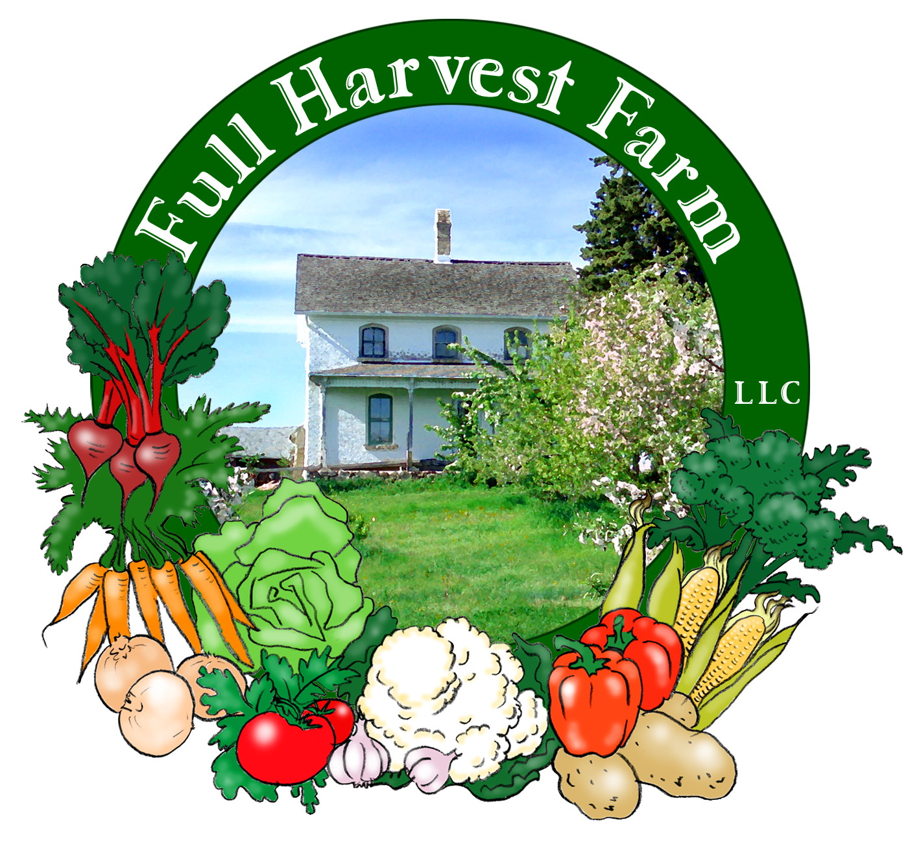
Full Harvest Farm, LLC
7112 County Road S
Hartford, WI 53027
262 673-6760
fullharvestfarm@gmail.com
http://www.fullharvestfarm.com
Box #14
Even Box
2 October 2024
Contents
Cilantro or Dill or Parsley
Bok Choi
Broccoli
Eggplant
Lettuce: Boston Bibb or Romaine
Pepper: Beaver Dam or Poblano or Red Bell
Tomatoes: Juliets, Brad's Atomic, Slicers
Watermelon
White Salad Turnips

New Stuff: bok choi, white salad turnips
Choice Box: peppers, tomatoes, ??

Bok Choi is a traditional vegetable in Asian cooking, often used in stir-frys. There are numerous types grown in the East, but only a few that are found in this country. You can spell it bok choy, bak choy or pac choi, and the shorter varieties are often labeled baby bok choy, etc.
However you spell it, and whichever type you grow,
bok choi is a nutritional gift, containing one of the highest levels of calcium around. It's also rich in vitamins A, B-complex, C and some minerals. And, it's low in calories.
Bok choi is a great favorite of flea beetles, who love the tender leaves. The small holes you find in some of the outer leaves of your bok choi are from these beetles. The holes do not change the flavor of the leaves, just make them a bit lacey looking.
Spicy Bok Choi with Sesame Noodles
Bring a pot of salted water to a boil.
Meanwhile, heat a wok of heavy skillet over high flame.
Add: 1 Tbsp. peanut oil
1 Tbsp. sesame oil
1 Tbsp. ginger, minced
2 Tbsp. garlic, minced
1/2 tsp. red pepper flakes
-Stir-fry for 30 seconds.
Add: 2 heads bok choi, stems separated, washed and cut into 1/2" pieces
8-12 mushrooms, sliced
1 sweet pepper, cut into chunks
-Stir-fry for 2-3 minutes.
Add: 1 cup chicken stock, or sake
2 Tbsp. soy sauce
-Stir, turn heat down to medium, cover and allow to cook 5-8 minutes longer.
If the water is boiling, add:
8 oz. linguine
-Cook, stirring occasionally so noodles don't stick together, until al dente. Drain noodles and return them to the hot pot.
Add: 1-2 Tbsp. sesame oil
Stir together so noodles do not stick to each other.
To serve, put some noodles into a bowl and top with the bok choi mixture.

White turnips, or salad turnips as they're sometimes called, are a sweeter, milder version of the classic, purple-topped, turnip. Turnips are high in potassium, vitamin C, and contain some iron, magnesium, calcium and vitamin B₆.
White turnips are white from top to bottom and all the way thru with tender, leafy green tops. Turnip greens are edible and have a spicy flavor. Because the leaf has tiny hairs on it, most folks choose to cook turnip greens rather than eat them raw.
Store turnips in the vegetable drawer in your refrigerator. The roots should keep for a few weeks, the leaves 4-5 days.
White turnips are especially good raw, in salads, coleslaw or as a snack, like radishes. You can roast them, braise them or put them in stews—very versatile.
There's a small critter called a wireworm that finds turnips, radishes, rutabagas and other brassicas very tasty. They are the larvae of click beetles, and eat their way into root crops. You may see some in the turnips as you cut them up. They aren't harmful, but I cut them out of my turnips and use the rest.

We had some beautiful, big bunches of cilantro and parsley left over from the West Bend Farmer's Market so some of you will get those. We cut off the bottoms and set them upright in water so they can absorb it and rehydrate. Now they look as good as new. Dill for everyone else. What's in your box?

I had this hors d'oeuvres at a wedding: It was a piece of grilled eggplant spread with Boursin cheese, then rolled up and secured with a toothpick. Delicious! Use my grilling sauce, or just brush both sides with olive oil, grill until soft and carry on with this simple recipe.

After looking through the pepper patch carefully, I did not find ripe FlavorBurst or Carmen peppers, as I hoped. So this week, you're getting either a Red Bell, a Beaver Dam or a Poblano pepper. Red Bell needs no explanation. Beaver Dam is a light green, cone-shaped pepper with a mild spiciness. Poblano is a shiny, dark green, cone-shaped pepper with medium spiciness. What's in your box?

By now, you're familiar with the large, grape tomato Juliet and the various slicing tomatoes we're growing, but Brad's Atomic is new. This purple, green, and yellow tomato is unusual and flavorful. Our plant produces a large, grape shape, but previous experience has seen them the size of small, round slicers, irregular heirlooms, even Romas. We thought you'd enjoy trying them.

These are the last watermelons of the season.

Field Notes
The ground is gradually drying out after that 2+" of rain. It would be nice to get another inch soon.
Frost is possible Wednesday morning. Well, it is October, and we were pretty lucky not to have gotten any in September. Tomatoes, peppers and eggplant are all susceptible to frost. To protect these plants from a light frost, we cover them with row cover, a lightweight polyester fabric. Row cover will keep some of the heat from the soil close to the plants, preventing too much damage from what should be a pretty light frost. After Wednesday morning, the forecast doesn't dip down too far until Monday and Tuesday mornings. We'll wait to see what actually happens.
Thursday we hitched up our potato harvesting rig and dug the rest of the spuds. What a harvest! There were so many potatoes going by the folks riding the harvester couldn't grab them all. I had to stop and start so they could keep up. This bounty is entirely due to Chuck cultivating and hilling the potato beds early in their life, and keeping it up so few weeds grew. The potatoes didn't have competition for water and nutrients from weeds, so they grew big and abundant. No shortage of potatoes this year!

Last Wednesday we had our annual organic inspection by MOSA (Midwest Organic Services Assoc.). It's always a rush to get all our ducks in a row for one of these, but we passed with flying colors. You'll be happy to know that the federal government has been more stringent recently on enforcing the organic law as it was originally written. Organic growers who get certified (and you must be certified if you make more than $5000/year in organic sales) have to keep detailed records on everything they use so the inspector can choose a seed packet, see the record of when it was seeded, where it was planted and when it was harvested. A lot of writing stuff down and organizing information to use the word "organic". Chuck and I feel that it's worth it for healthier, tastier vegetables.

Please keep bringing back those wax boxes so we can reuse them. Our pile is getting rather low. Thank you.

Enjoy this milder weather.
Take Care,
Terry & Chuck

