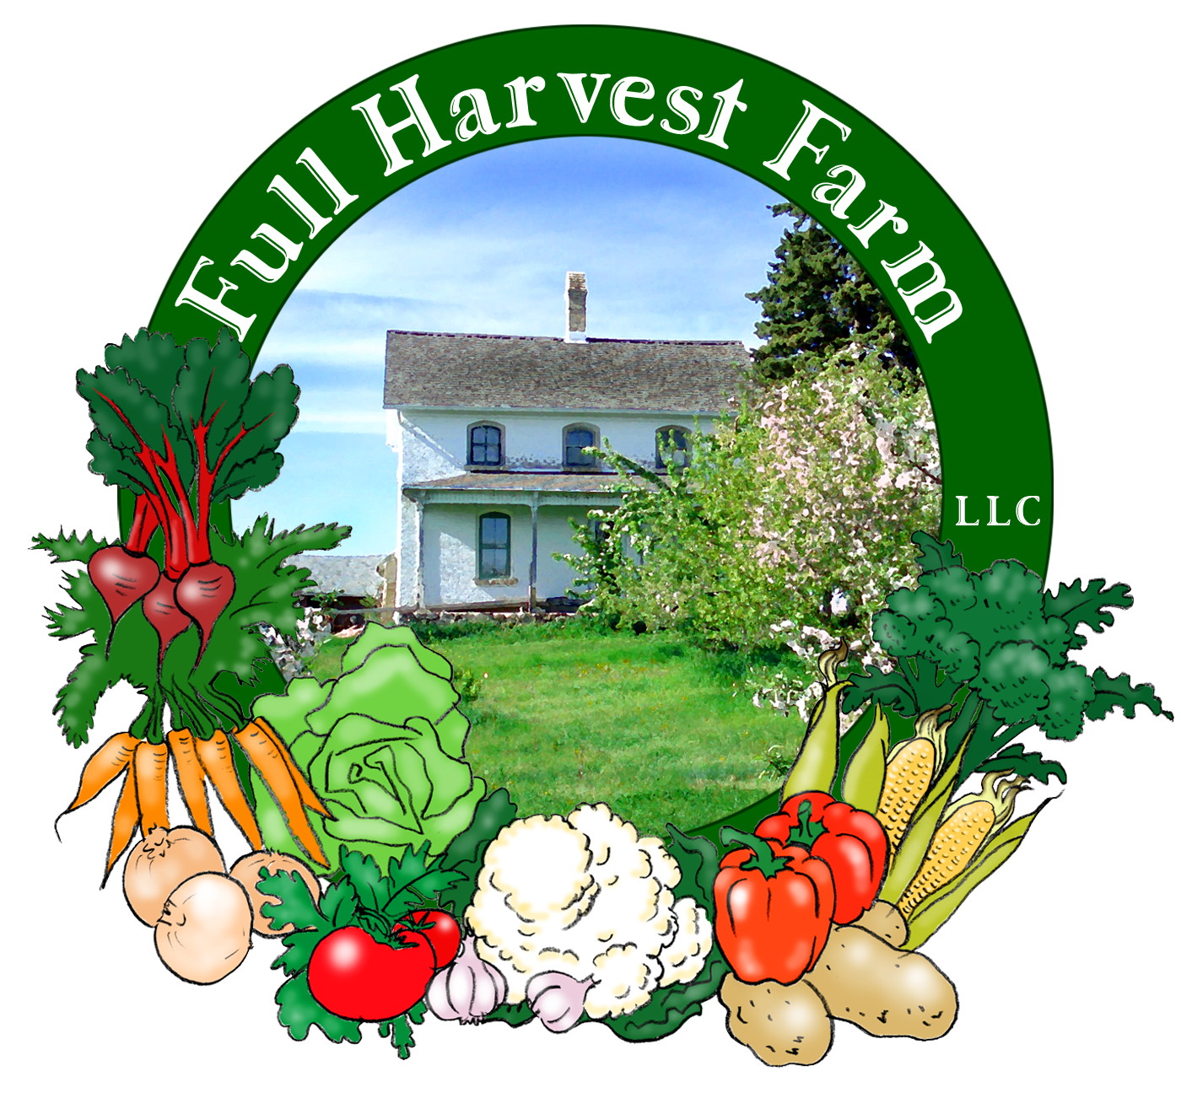
Full Harvest Farm, LLC
7112 County Road S
Hartford, WI 53027
262 673-6760
fullharvestfarm@gmail.com
http://www.fullharvestfarm.com
Box #13
Odd Box
25 September 2024
Contents
Dill or Cilantro
Beets: Chioggia/Orange/Red
Broccoli Raab
Garden Mix: Couple Shares
Garden Mix and Lettuce: Family Shares
Kohlrabi
Pepper: Green Bell
Tomatoes
Watermelon

New Stuff: Garden Mix, watermelon
Choice Box: cucumbers, tomatoes, ??

Garden Mix is a blend of all the different kinds of lettuce we grow plus a few more, picked when small and mixed together. This is a popular item at our West Bend Farmer's Market stand. We had extra, so you get some this week too.

These watermelons are designed to be small so they fit inside a CSA box. Chuck and I find that watermelons with seeds have more flavor that the seedless varieties, so these have seeds. We should have enough to put them in next week's box also. Then that'll probably be the last of the melons for this year.

The current beet patch has lots of every kind of beet we're growing. Bunches are either all one kind or a mix of each. Surprise!

Broccoli raab can be also be made using Terry's Favorite Way To Cook Any Vegetable. If you like arugula or mustard greens, you'll probably love broccoli raab. The bottom of the stalk can be fibrous, so pull off the leaves from that part and use them, discarding the fibrous stalk. The top portion is pretty tender, and you can chop the stalk and leaves together.
Here's another recipe using broccoli raab:
Broccoli Raab Lasagna
FOR THE BÉCHAMEL SAUCE:
4 tablespoons butter
¼ cup all-purpose flour
2 cups whole milk, heated, or Half & Half
Salt and pepper
Pinch of cayenne, optional
Grated nutmeg, to taste
FOR THE LASAGNA:
1 pound dry lasagna noodles
Salt and pepper
1 bunch broccoli rabe, about 1 lb.
1 pound ricotta cheese
½ teaspoon grated lemon zest
1 tablespoon butter
4 ounces grated Parmesan, about 2 cups
PREPARATION
Make the béchamel: Melt butter in a small saucepan. Whisk in flour and cook for a minute over medium heat without browning. Gradually whisk in heated milk or Half & Half, 1/2 cup at a time, to obtain a smooth, thick sauce. Turn heat to low. Add 1/2 teaspoon salt, some ground black pepper, the cayenne and nutmeg. Simmer, whisking, for 4 to 5 minutes, to cook out the flour taste.
Bring a large pot of well-salted water to the boil. Add lasagna noodles and cook for 5 minutes. Remove noodles from water with a spider or slotted spoon and rinse well in a bowl of cold water. Drain and lay noodles flat on a kitchen towel.
Using the same cooking water, blanch the greens for 1 minute, until just wilted. Rinse greens with cool water, squeeze dry and chop them roughly.
Mix the ricotta and lemon zest in a small bowl and season with salt and pepper to taste. Heat oven to 375 degrees. Organize all ingredients so they are within easy reach for assembling lasagna. Use 1 tablespoon butter to grease an 8-by-10-inch baking dish.
Assemble the lasagna: Put a layer of cooked noodles on the bottom of the baking dish. Spoon a quarter of the béchamel over noodles, then dot with a third of the ricotta. Complete layer with 1/3 of chopped greens, and some grated cheese. Continue layering, finishing with a layer of pasta. Spread the last of the béchamel on top and sprinkle with Parmesan. (There should be 4 layers of pasta and 3 layers of filling.)
Dot with remaining butter and bake, covered with foil, for 20 minutes. Uncover and bake for 20 minutes more, until nicely browned and bubbling. Let lasagna rest 10 minutes before serving.

Looks like the FlavorBurst peppers will need another week to ripen, so just a green pepper this week. The green peppers are starting to mature to red. We'll see how they're looking next week, and try to put those in as well.

Our tomato patch is starting to produce more fruit. Since the forecast calls for a warmup and no frost, we're hoping to give you tomatoes for several weeks yet. Fingers crossed.

Field Notes
Sunday's on-and-off, all-day rain dropped 2" or more on the farm--hooray! After that long, dry spell, this was exactly what the plants needed because, with a long, steady rain, the moisture has time to soak into the ground and really nourish the plants.
Chuck's got another broccoli bed that's starting to form harvestable heads. Looks like broccoli in next week's box.
White salad turnips are a late crop for us this year. Chuck thinks there's a smaller chance of wire worm damage that way. We harvested some this week, and it looks like he's right. You'll probably get some of these in the next box.
Another item that's looking good is our bed of Napa cabbage and baby bok choi. I think a few weeks on the bok choi will do it, then they'll be large enough to harvest. Napa cabbage should take longer, but look for them in the last few boxes.
And there will be leeks in those last few boxes too. We'll start to thin the bed soon, but many have reached a decent size.

And that's it for this week.
Enjoy the milder, fall weather.
Terry & Chuck

