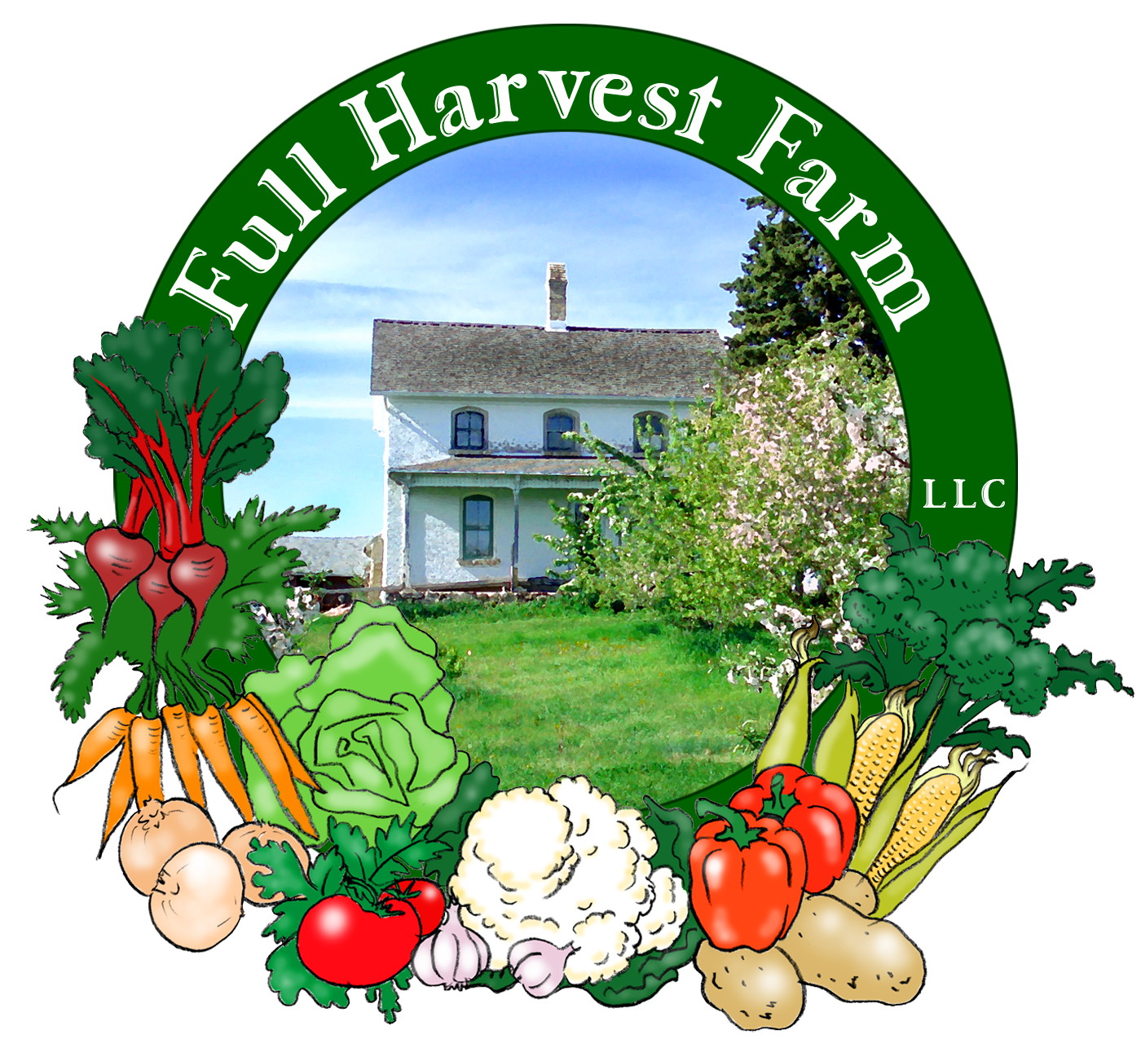
Full Harvest Farm, LLC
7112 County Road S
Hartford, WI 53027
262 673-6760
fullharvestfarm@gmail.com
http://www.fullharvestfarm.com
Box #12
Even Box
18 September 2024
Contents
Broccoli Raab
Eggplant
Lettuce: Green Romaine
Onions
Patty Pan Squash
Pepper: Green Bell
Potatoes
Tomatoes
Muskmelon

New Stuff: broccoli raab, muskmelon
Choice Box: kale, chard, damaged peppers, radishes, etc.

Broccoli raab, also called broccoli rabe or rapini looks like leafy broccoli. The heads are thin and wispy, with green buds and yellow flowers. Broccoli raab has a nutty, sharp flavor, similar to arugula. The stalks, leaves, buds and flowers are all edible. An easy way to clean it is to chop the bunch into ½” pieces, put into a salad spinner and wash as you would lettuce.
Broccoli raab is high in vitamins A and C, and contains calcium, iron, magnesium and vitamin B-6. Store it in a plastic bag in your refrigerator, and use it up within 3-4 days.
If the flavor is too sharp for you, blanch broccoli raab for 2 minutes in boiling water. Drain, and add to whatever dish you’re making.
The broccoli raab in your bunches contains mostly leaves with small heads here and there.
Since it's so leafy, broccoli raab doesn't handle frost well, so we try to put it into your boxes before frost happens. There's a chance of that this Friday morning--we'll see.
Broccoli Raab with Pasta
Put a pot of salted water on high heat for the pasta.
In a 10” skillet over medium heat, put:
3 Tbsp. olive oil
3 Tbsp. butter
Add: 1 medium onion, sliced into quarter moons
3 garlic cloves, chopped coarsely
red pepper flakes optional
Sauté until the onion is getting just a little brown around the edges.
Add: 1 bunch broccoli raab, washed and cut into ½” pieces (a salad spinner is very handy here)
Cook, stirring often, until the raab starts to wilt, about 5 minutes.
Add: 1 cup chicken stock
1 cup heavy cream
Bring to a simmer, then turn the heat to low and cook another 5 minutes or so, until the broccoli raab is tender.
While this cooks, chop up some fresh tomatoes and put them into a bowl.
To the broccoli raab, add: salt and pepper to taste
Cook pasta until al dente. Drain, return to hot pot and toss with olive oil.
To serve, put pasta into a bowl, top with broccoli raab sauce, some of the chopped tomatoes and grated cheese. Enjoy!
Any of the recipes I've given you for chard are good ones for broccoli raab. And the 'net is always a good place to search for ideas.

Melons, so good when they're ripe, so disappointing when they're not. This season, we grew 2 kinds: muskmelon and watermelon.
People often ask us "How do you know when a melon is ripe?" There are a couple of ways. First, look for the ground spot: it should be yellow. A "ground spot" or "field spot" is the place where a melon's skin rests on the ground while it grows. When a green melon matures, its ground spot turns from green to yellow. The deeper the yellow, the more mature the melon. Even yellow melons have yellow ground spots, they're just a different shade. The next way is overall color. Muskmelons have a green undercolor that turns to beige/yellow/orange when it's ripe. If a melon has ribs, like a muskmelon does, those ribs should be brown or beige instead of green. Canary melons turn a deeper shade of yellow. Color is tough to use as a measure on watermelon, tho. Look for a yellow ground spot on those, not white or light green. The last way is smell. A ripe muskmelon or canary or honeydew should smell wonderful. Again, this is a hard one to use on watermelons because they don't have a strong smell and that thick rind blocks most scent, but experts say a ripe watermelon will smell slightly sweet. Lots of people say to thump a melon with your finger and listen for a "plunk" sound. This would be easier if you had melons of different ripenesses to test all at the same time for comparison.
You're getting a small muskmelon this week. Chuck likes it because it matures relatively quickly, fits into the boxes easily and tastes good. Some muskmelons have what I like to call "sugar spots". These are dark brown patches on the rind that are a little sunken, and are an indication that a melon is very ripe. I tasted several melons Tuesday, and the one that tasted the best had "sugar spots" on it.
Chuck is pleased that the watermelons ripened despite the vines dying early. You'll get those in following boxes.

Those eggplants are going gangbusters. So, here's a novel way to use them up:
Eggplant Fries
1 cup All-Purpose flour
2 Tbsp. Kosher salt, plus 1 tsp. for seasoning
1 tsp. freshly ground black pepper
3 large eggs
1 cup Panko breadcrumbs
½ cup grated Parmesan cheese
1 medium eggplant (about 1 ½ lbs.)
Place 2 racks in the upper and middle thirds of the oven and preheat to 425 degrees F. Place a wire rack on a large baking sheet.
Whisk together the flour, salt and pepper in a large bowl. Lightly beat the eggs in a medium bowl. Combine the panko and the Parmesan in another medium bowl.
Slice off both ends of the eggplant. Cut the eggplant in half lengthwise and slice each half into ½ to ¾” thick layers, then cut each layer into ½” sticks. After all fries are cut, drop them into the flour and lightly toss them to coat evenly. Working in batches of a few at a time, dip the floured fries into the egg and then into the panko mixture. Place the fries on the wire rack in the baking sheet, leaving an 1/8” space between each.
Bake the fries until they are golden brown, about 15 minutes. Season the fries with the remaining salt.

Something is making a small, perfectly round hole in some of the peppers. We're not sure what it is exactly--slugs, caterpillars, corn borers, whatever--but the rest of the pepper is fine. I've cut into several, and not found anything inside that might shed some light. So this week, in my quest to prove that slightly damaged vegetables are still perfectly edible, I've given you an undamaged pepper, and one with a little round hole or 2. Please let me know if you find any clue as to what is making them, or if you know, please email.

This week, the cherry tomatoes are starting to ripen, so many of you will get a few cherry or small grape tomatoes along with your Juliets and slicers.

Field Notes
Hot, sunny, dry--we're just glad the humidity remains low. Chuck is busy laying out fresh water lines to our fields--some of our old fire hose sprung leaks and needed to be thrown away, so Chuck brought out his backstock. A good farmer always has a Plan B.
Of course, warm weather means the growing season will likely be longer than normal. With tomatoes just beginning to produce, longer is better. Who knows, this could be the first year we put tomatoes in Box #18.

That's it for this week. Bon Appetit!
Terry & Chuck

