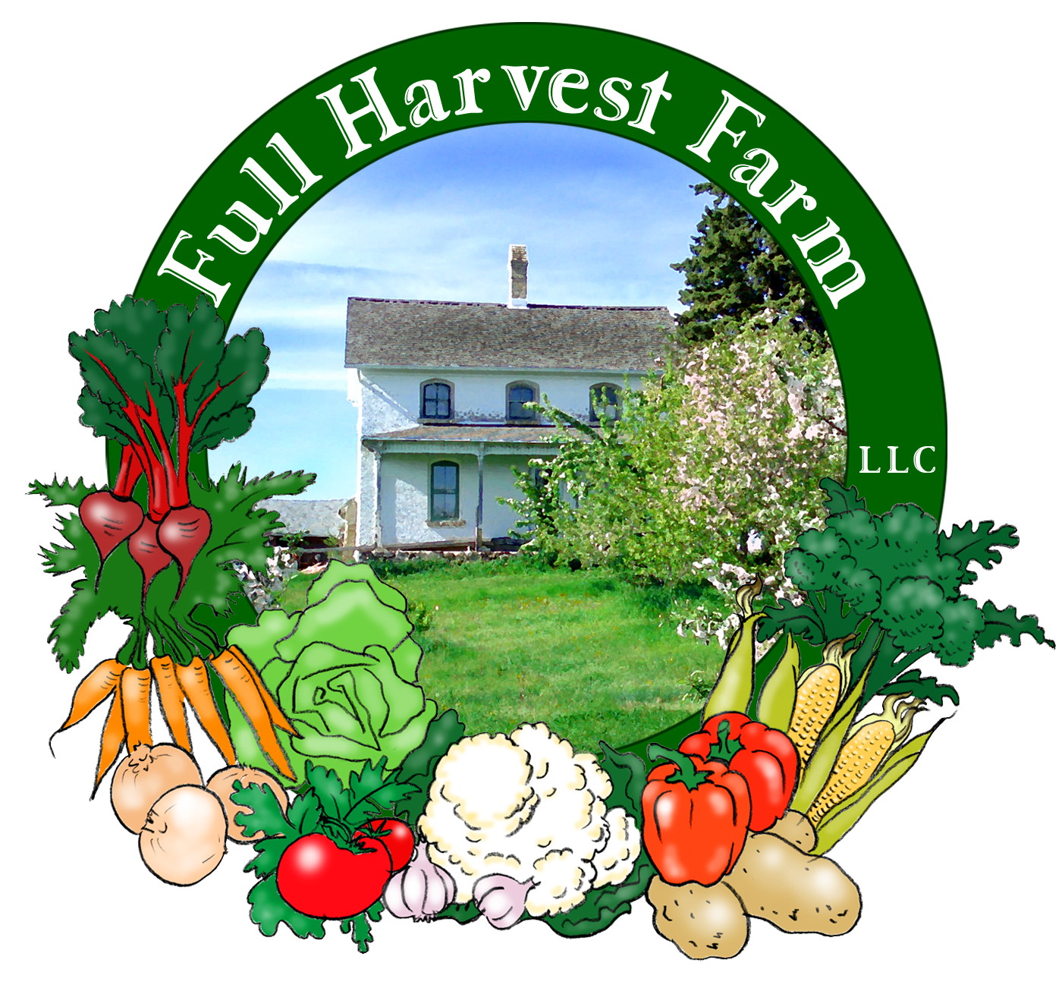
Full Harvest Farm, LLC
7112 County Road S
Hartford, WI 53027
262 673-6760
fullharvestfarm@gmail.com
http://www.fullharvestfarm.com
Box #11
Odd Box
11 September 2024
Contents
Cilantro
Carrots
Eggplant
Kohlrabi
Lettuce
Pepper: Green Bell
Radishes
Sweet Corn
Tomatoes:

New Stuff: tomatoes
Choice Box: ??

Tomatoes are native to Peru, and were first cultivated by the Aztecs and Incas in the 8th century. The word tomato comes from an ancient Mayan word "xtomatl.
Europe got its first tomatoes via the Spanish explorers in the 16th century, altho many thought they were poisonous. The Italians embraced them first, followed by the Spanish and French. Now, we can't imagine a dish of spaghetti without them.
Store tomatoes, uncut, at room temperature. I have a bowl for them on my counter. They will keep for about a week or more, especially if they are ripening. If you cut into one and can't use it all, refrigerate it, but use the cut one quickly.
Tomatoes get redder and softer the riper they are. Well, if they're normally red when ripe, that is. Most tomatoes start off green, change to light green, yellow to orange, then finally thru orange to red. Sometimes, in future boxes, you will get tomatoes that are still in that orange-red stage. As they sit on your counter, you will see them change to red. The flavor gets a little better too. Worth the wait.
Now let's define some terms that Chuck and I throw around a lot: cherry, grape, slicer, paste. A cherry tomato is small, round and measures 1" or less. A grape tomato is small, oval and measures 1"-1 ½". A slicer is medium to large, roundish and juicy—the kind of tomatoes folks use on sandwiches, salads, etc.. A paste tomato is medium-sized, oval to long, has little juice and lots of pulp—the kind often used to make tomato sauce.

Chuck and I grow lots of different kinds of tomatoes every year. One of our favorites is Juliet, a large grape tomato. It has great tomato flavor, ripens early, and produces loads of bright, shiny fruit. It's not a juicy tomato, so makes a great salsa.
We've got the "Sweet 100" red cherry, an orange cherry called "SunSugar", grape tomatoes called "5 Star Grape", a crazy one named "Brad's Atomic" that's purple and green, and several others I can't recall—a fun mixture.
Chuck and I grow several types of slicers. Some are smaller (Mountain Merit), some are larger, some are multicolored, yellow and pink (Hillbilly), some are green and red (Black Krim). We choose the varieties for their flavor, productivity, and tendency to NOT crack. We like to grow some heirloom slicers. These tend to be quite large, irregularly shaped, and may ripen unevenly, but boy, do they taste good.
We've also planted San Marzano, a paste tomato that makes great sauce, and Amish Paste, which doubles as a slicer.
An easy way to store extra tomatoes is to freeze them whole. I wash mine, put them into the freezer anyplace they'll fit, then throw them into a ziplock freezer bag once frozen. This way, they don't clump together. If you just need one or two for a dish you're cooking, pull it out of the freezer, chop and add. If you don't like the skins, run some warm water over the frozen tomato. The skin will split and you can peel it away easily. Then chop and cook.
You may not have enough tomatoes to make this, but file it away for the future (or the next farmer's market).
Cold Tomato Soup
In a blender or food processor, put:
2 lbs. tomatoes, washed, cored, coarsely chopped
½ onion, coarsely chopped (1/4 to ½ cup)
1 clove garlic
1-2 tsp. red wine vinegar
2 Tbsp. good-quality olive oil
½ tsp. cumin, ground
1 tsp. Pimenton/smoked paprika -optional
½ tsp. Kosher salt
½ tsp. freshly-ground pepper
-Process all ingredients until everything is finely pureed. Store in refrigerator until ready to eat. Soup is better if allowed to sit for 2-4 hours so the flavors can “swap around”.
Optional ingredients: cucumber, peeled and seeded; peppers, sweet or spicy; parsley; basil; anything else you think would be good in this soup.

After this week, we're giving you a break from carrots. They will definitely be in the last 3-4 boxes of the season.

The eggplant patch is going great--lots of fruit and flowers, so as long as the weather stays warm, we'll have eggplant--altho you probably won't get it in every box . . .
Here's another good recipe using eggplant:
Baba Ghanouj/Baba Ghanoush
1 large eggplant
1 Tbsp. lemon juice
2 Tbsp. tahini
2 garlic cloves, peeled
2 Tbsp. olive oil
salt and pepper to taste
Preheat oven to 375°F. Cut eggplant in half lengthwise and place on sheet pan. Brush with about 1 tablespoon olive oil and season with salt and pepper. Roast for 40-45 minutes until very soft.
Let eggplant cool before handling. Scoop eggplant flesh out of skins into the bowl of a food processor. Add lemon juice, tahini, garlic, olive oil and salt and pepper. Process until smooth. Spread on crackers, bread or use as a dip with fresh vegetables.

I was happy to see that the pepper patch is looking very good indeed. The plants have a nice covering of dark green leaves and a good set of fruit. I could wish for a few more flowers, but hey. The Italian Carmen peppers have reached full size, now we wait for them to turn red--they're so good when fully red. This is a sweet pepper with delicious flavor, especially grilled.

Chuck's radish patch is producing beautifully. We may have these in next week's box--who knows?

Lo and behold, some extra sweet corn! This is absolutely the last of the season.

Field Notes
Altho we've had a few rain showers, none have lasted very long or dropped much moisture. Chuck has been running pipe out to our fields and laying drip tape to give everything a drink on a timely basis.
The cucumber patch is slowly succumbing to disease. It seems like the vines grow great for about a month, then start to die suddenly. We're not sure whether it's bugs or disease. But the leaves have turned a light green (until they turn brown) and started dropping their flowers and new fruit. You're unlikely to get any more cucumbers in your boxes this season.
The 2nd zucchini/patty pan squash patch shows mixed results. While the zucchini caught some disease and died shortly after starting to show fruit, the patty pan squash are looking healthy and bearing. We picked a first few Tuesday morning. Fingers crossed they continue to be productive.

And that's it for this week.
Enjoy this stretch of beautiful weather.
Cheers,
Terry & Chuck

