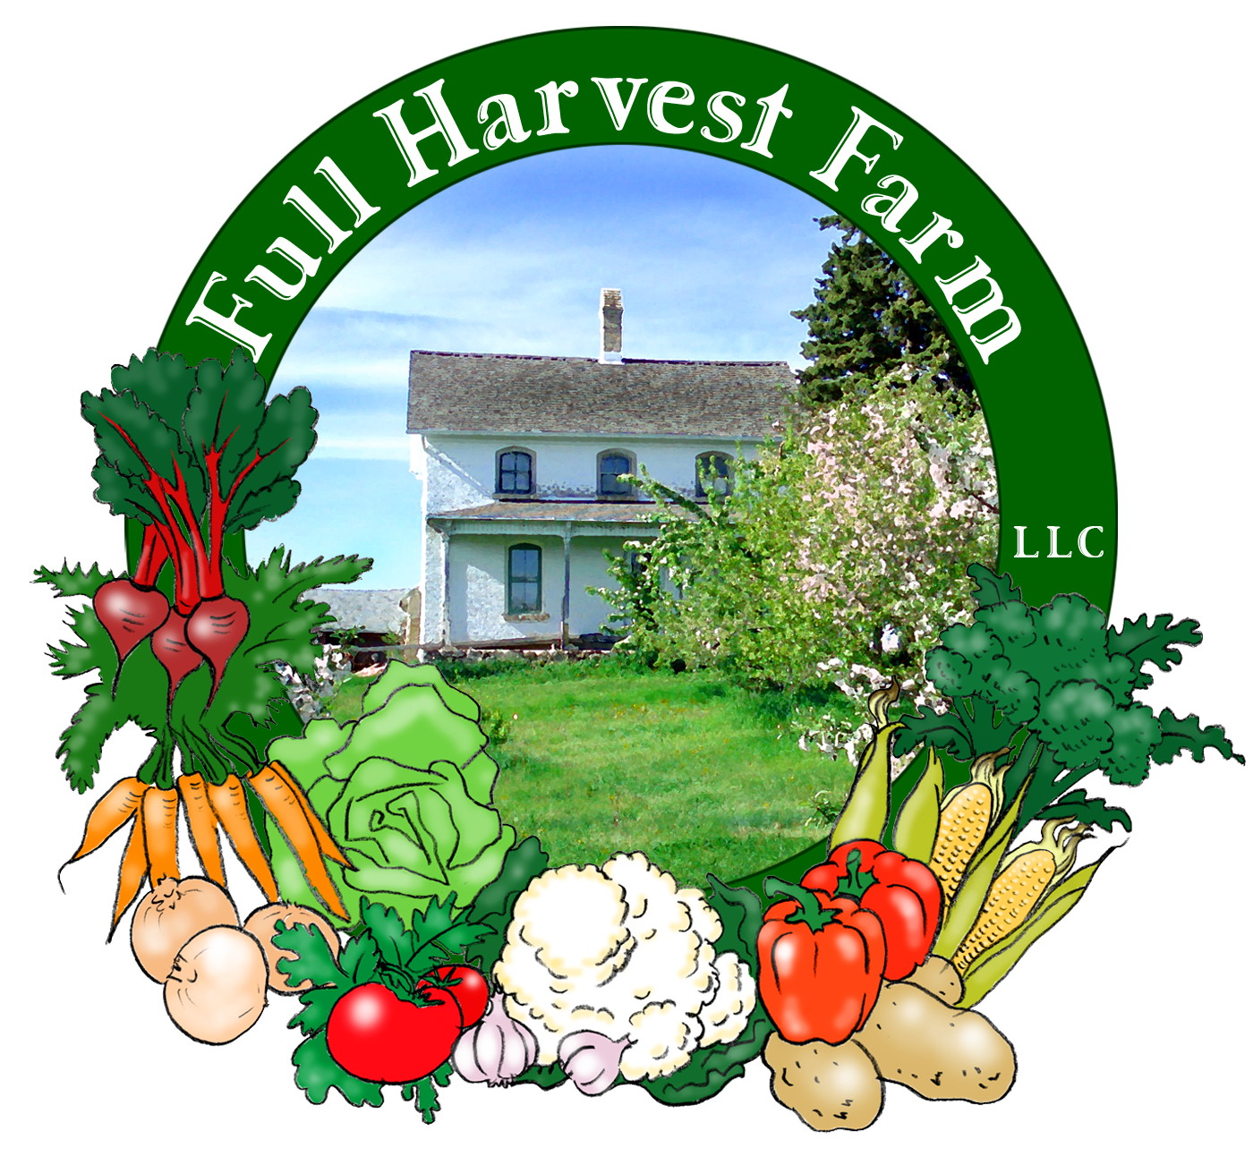
Full Harvest Farm, LLC
7112 County Road S
Hartford, WI 53027
262 673-6760
fullharvestfarm@gmail.com
http://www.fullharvestfarm.com
Box #10
Even Box
4 September 2024
Contents
Beets: Chioggia, Mixed or Red
Broccoli
Carrots: Orange & Yellow
Cucumbers
Eggplant
Lettuce
Pepper: Green Bell
Sweet Corn

New Stuff: eggplant, green pepper
Choice Box: damaged peppers, ?

Altho eggplant is low in calories and high in fiber, it does not contain large amounts of vitamins or minerals. It is available in many, different cultivars, from the large, pear-shaped, Italian variety, the long slender Asian, the small white “chicken egg”, to others that are pink, green, lavender, striped and so on. This year, we planted some Asian-style eggplant that are long, slender and black. Also a smaller, purple, pear-shaped variety. Thankfully, they're both producing really well. The Asian variety has a tender skin and sweet flesh. I haven't tried the small, pear-shaped one yet, but anything on the small side should have tender skin.
I'm a big fan of grilled eggplant, and the grilling sauce I use makes it taste like beef.
Grilling Sauce for Eggplant and Zucchini
In a small bowl, whisk together:
¼ cup olive oil
1 Tbsp. balsamic vinegar
1 Tbsp. soy sauce
salt & freshly ground pepper
Soy sauce helps to emulsify the vinegar and oil. Wash the eggplant(s), and cut off the tops, no need to peel. Slice them into lengthwise slabs, ½” thick. Brush both sides with the grilling sauce. Grease your grate, and grill the slices over the coals, turning as needed. They’re done when you can’t see any whitish streaks, and the slabs are moist and limp.
Always cook eggplant before eating as it contains a toxic substance called solanine. This is the same, bitter material that makes green potatoes taste bad. Cooking eggplant changes the solanine chemically so it’s safe to eat. Store eggplant in the vegetable drawer in your fridge, but use it within a week.
One of our CSA members sent me this recipe way back in 2016. It's now a summer favorite:
Mediterranean Ratatouille Chicken
1 lb. boneless, skinless chicken breast, cut into large strips (or whole chicken thighs)
1 clove garlic, crushed and minced
1 cup eggplant, cut into ½ inch cubes
1 small zucchini, thinly sliced
1 medium onion, sliced
1 small green pepper
1 14 ½ oz. can diced tomatoes
2 tsp. capers, drained
4 tsp. Parmesan cheese
12 oil-cured olives, like Kalamata
8 leaves fresh basil, chopped (or ½ tsp dried)
2 Tbsp. olive oil or olive oil cooking spray
Spray a 10 inch frying pan with cooking spray (or use the 2 TBSP Olive Oil). Heat to medium hot and put chicken strips in frying pan. Add garlic. Turn chicken once when lightly browned.
Add all other ingredients except basil and Parmesan cheese. Cover and simmer for 15 min (or 30 if using thighs) until vegetables are tender and chicken is cooked through.
Stir in basil, simmer 2 minutes, then sprinkle cheese on top and serve immediately with pasta or bread sticks.

Peppers contain high levels of vitamins A, C and E, as well as iron and potassium. To get the greatest benefit, eat them raw. Store peppers in your crisper drawer with the other vegetables. They should keep for about a week or more. If you can't use up a whole pepper in whatever you're making, keep the remainder in your frig and use it ASAP—the edges start to break down in 4-5 days.
When young, most peppers are green with thin walls and a sharp, slightly bitter taste. As they grow and mature, the walls thicken, green changes to red, orange or yellow, and they sweeten up. This color change takes an extra 20-25 days for most varieties, and is most noticeable in sweet peppers
Chuck and I planted several different varieties of peppers this year. Our sweet bell peppers are Olympus, Red Ace, and Flavorburst.
In order to have a good supply of green bell peppers without robbing the patch of fruit that will turn color, we decided to plant a bell pepper to pick when it's still green, and let other cultivars fully mature. Olympus was our choice for that spot as it produces some absolutely huge peppers. This is the bell pepper in your box this week. Red Ace is the one we'll let turn fully red before harvesting. Flavorburst starts out as a light, green bell pepper with mild flavor, then turns yellow/orange, and finally reddish. Yellow is when its flavor really punches up, so that's when we'll start picking. Believe me, you'll be glad we waited.
We always plant a sweet, Italian pepper called Carmen. It's long, cone-shaped and best when fully red. Carmen is probably the best-tasting pepper we grow, altho Flavorburst is giving Carmen a run for its money.
Chuck is committed to Shishito peppers. They are green, slender, wrinkled, and about the size of a large Jalapeño. Shishitos are excellent on the grill, or dry-roasted in a cast iron pan. Most of the time, they are sweet. About 1 in 10 will be spicy at about the level of a Jalapeño.
An unusual pepper we're growing this year is Poblano. This is considered a "sweet" pepper, and the one that is stuffed for Chile Rellenos.
For a mildly spicy pepper, we're growing Beaver Dam. This pepper was brought to Beaver Dam, Wisconsin by Hungarian native Joe Hussli in 1912. The heat level ranges between 500-1000 SHU's (Scoville Heat Units), which is pretty mild. Jalapeños score around 5000 SHU.
What, no Jalapeños? Sadly, no. We thought we had put some aside for the field, but, when it came to planting, we found no Jalapeños with the rest of the peppers. Sigh.

This week your box contains broccoli side shoots. Most broccoli varieties readily produce side shoots after the large, middle head has been cut. We had a good-sized patch of broccoli, so, lots of side shoots. Kind of an extra bonus.

Crécy is a small town south of Paris that is famous for its carrots. This is a simple soup, by which I mean it has few ingredients and relies on the main vegetable for most of its flavor, so, that main vegetable better taste pretty good—as do our carrots.
Potage Crécy or Carrot soup
In a 4-quart pot over medium-low heat, put:
3 Tbsp. butter
1 cup onion, chopped -more, if you like
½ tsp. freshly ground pepper
Sauté the onions slowly until they are tender and translucent.
Add: 6 cups chicken stock
1 lb. carrots, scrubbed and chopped (about 4 cups)
Bring the soup to a simmer, covered, and simmer until the carrots are very soft. (The smaller you chop your carrots, the quicker they cook.)
Puree the soup (I use a hand blender with the pot off the heat). If the soup is too thick, add more chicken stock or water until it reaches the consistency you prefer.
Taste for salt and pepper and adjust these as needed.
If you want a more elegant soup, add some heavy cream to the puree, heat to steaming and serve.
You can use this same recipe for broccoli, cauliflower, parsnips, beets, celeriac, etc. As long as the main vegetable tastes great, so will your soup.

Lettuce is back in the mix. The next beds are sizing up, altho not yet Large. We figured a modest head was better than none. More next week.

This is the last of the sweet corn for this season.

Field Notes
Chuck seeded some radishes out in the tomato field and we are pleased to report they are pushing out of the ground.
Speaking of tomatoes, which I'm sure you're wondering about, I can tell you that there's lots of green fruit on those plants. When we'll get a reasonable amount of red . . . well, we're hoping for next week. Once they start to turn, they ripen faster and faster. Then, you'll get alot.
Tomatillos are ripening too. Salsa Verde!
There's some disease killing the watermelon vines. Not sure what it is, but the vines are slowly turning brown. We have some good-sized fruit, so are hoping some of that ripens before those plants are completely dead. Fingers crossed.
The muskmelons look much better, with a few early ones starting to turn from green to beige. Once they're completely beige under the netting, those melons will be ripe.

Enjoy this late summer weather.
Cheers,
Terry & Chuck

