
Full Harvest Farm, LLC
7112 County Road S
Hartford, WI 53027
262 673-6760
fullharvestfarm@gmail.com
http://www.fullharvestfarm.com
Box #9
Odd Box
28 August 2024
Contents
Cilantro
Beets: Red
Broccoli
Carrots: Orange
Cucumbers
Kale
Kohlrabi
Sweet Corn

New Stuff: sweet corn
Choice Box: ??

Sweet corn is one of summer’s treasures. Who doesn’t love a freshly-cooked ear, dripping with butter and sprinkled with salt and pepper?
Corn has been around for tens of thousands of years, and seems to have originated in Central America. Early varieties were small, brightly colored, and a popcorn-type. Over the centuries, strains have been selected for size and sweetness, as they are today. Altho not as nutritious as older varieties, today’s sweeter corn still contains vitamins A, B-complex, phosphorous, potassium, vegetable proteins and complex carbohydrates. Combined with most beans or dairy, it forms a complete set of proteins.
Sweet corn is best eaten as soon after harvest as possible—this was picked Tuesday. The longer you keep it, the more sugar will change to starch. Store sweet corn in its husk in a plastic bag in the refrigerator.
You may find that some of the ears have ends with very small, immature kernels, and, a little further down, the kernels are suddenly much bigger. This is a result of uneven fertilization. Corn silk is a conduit that helps each kernel of corn develop. If some of those strands are not pollinated, some of the kernels will not form. Bugs can also interrupt fertilization when they eat the corn silk, which is why commercial farmers spray insecticides.
I like to cook my sweet corn with a cup of water in a skillet, a teaspoon of salt, then the husked ears. Bring the salt water to a simmer, cover, and cook for 5 minutes. Turn the ears with tongs, and cook for 5 more minutes. Ready for butter! Save the tasty corn water for soups or other recipes where you need a little stock.
Sweet corn is great on the grill. Leave the husk intact, and soak your corn for about 30 minutes in a bucket of cold water. Prepare the coals as usual, and spread them out over ½ or 1/3 of the bottom of the grill. When ready, place the ears on the grill rack directly over the fire. With a tongs, turn the ears a quarter about every 5 minutes. Don’t worry if the husk gets charred, that adds flavor to the corn. When you’ve grilled all sides, move the corn to the cool side of the grill, and remove the bits of husk and silk from the rack. Now, cook your meat on the hot side. When the meat is almost done, pile the corn on a platter to cool a bit before serving. When it’s cool enough to handle, remove the charred husk and enjoy.
This year, we 're growing only 1 type of sweet corn: Café. Café is a smaller plant that matures early with excellent flavor. We've grown it for several years.
Raccoons love sweet corn and they're very destructive about how they look for ripe ears. They reach up for an ear that smells good, pull it down, rip the husk open and taste the kernels. If they don't like it, they move on.
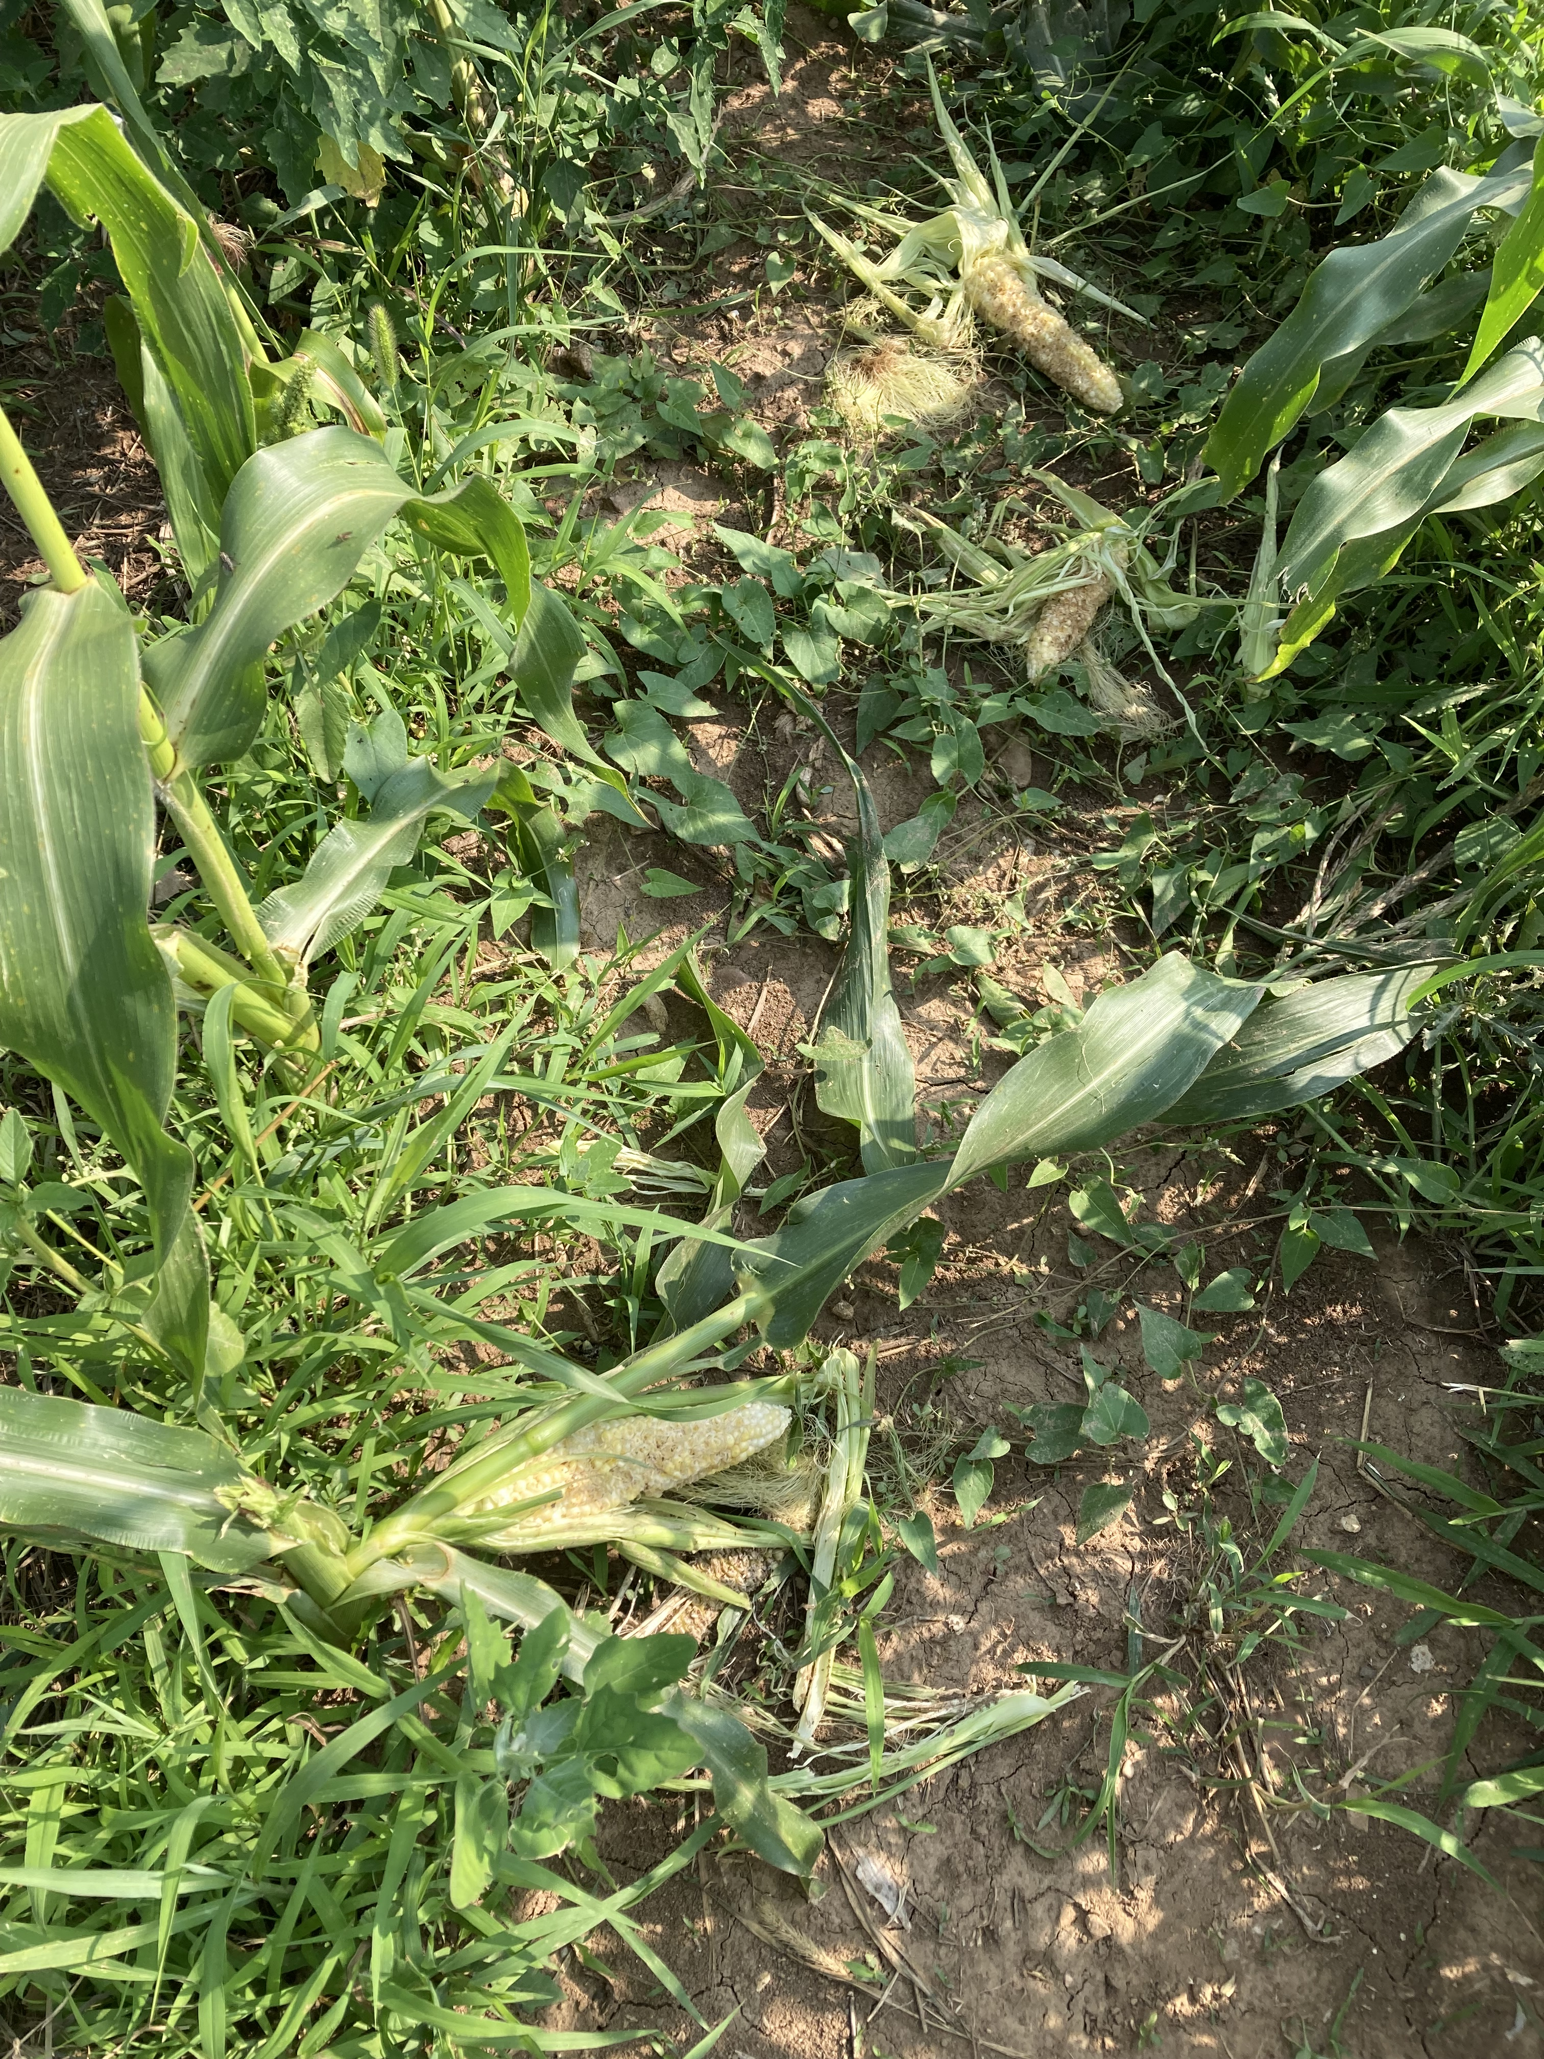
In this picture of raccoon damage from last year, you can see a stalk that's been broken and several ears on the ground partially eaten. There was very little usable sweet corn left in that patch after the raccoons devastated it last year. Protecting it with an electric fence is an absolute necessity.
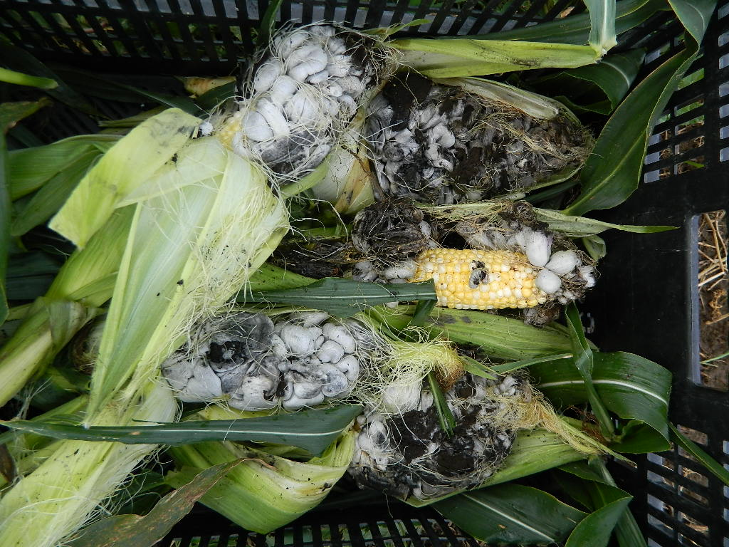
Another foe of sweet corn is Corn Smut. This is a fungal disease that causes the kernels to turn gray, then black, and grow very large. The Mexicans call it "huitlacoche" and consider it a delicacy. The flavor is described as strong, mushroomy, inky, woodsy, and not all that great by itself. Folks love it cooked with onions, garlic and peppers and eaten wrapped in a tortilla. According to my online research, huitlacoche contains all the essential amino acids and is rich in lysine, glycine and leucine. It also has several minerals, vitamins, antioxidants, omega fatty acids and is easy to digest. If you want to experiment with huitlacoche, we'll pick some ears and put them in the Choice Box.

The next patch of beets is big enough to harvest. Here's another recipe:
Beet Relish
2 pounds (907g) whole beets, washed and cut into large, even chunks
Wrap beet chunks in foil, place on a sheet pan and roast at 400 degrees until fork tender. Steaming them is another option.
While the cooked beets are cooling, make this:
In a small saucepan over medium heat, put:
1 cup (237ml) apple cider vinegar *see Note
½ cup (64g) granulated sugar *see Note
¼ teaspoon celery seed
½ teaspoon salt
-bring the mixture to a simmer and cook until the liquid is reduced by half.
In a small bowl, put:
½ teaspoon corn starch
1 tsp. water
Whisk together and mix into the vinegar. Simmer until thickened. Remove from heat.
Chop beet chunks into desired size, or put beets into a food processor and process in 1 second bursts until finely chopped. Put into a bowl.
Pour vinegar mixture over the beets, mix well.
Allow to cool to room temperature. Transfer to clean jars. Refrigerate.
* NOTE: To make the relish less sweet and a bit more vinegar-y, use 1/4 cup of sugar and keep the vinegar at 1/2 cup.

This patch of Kossak kohlrabi have reached their full size, so it's time to harvest. Remember, this cultivar is a long keeper. If you don't cut it, the globe will stay tasty for months in your refrigerator crisper drawer.
Cucumber, Kohlrabi and Carrot Salad
In a medium salad bowl, put:
1 small onion, cut in half and sliced thinly
1 medium cucumber, cut in half and sliced into thin half-moons
1 carrot, scrubbed and cut into julienne matchsticks
½ kohlrabi, peeled and cut into julienne matchsticks
-Toss vegetables together to mix them and break up the layers of onion.
Dressing: in a small bowl, put:
1 Tbsp. light soy sauce or Tamari
2 tsp. rice or black vinegar
1 tsp. sesame oil
1 Tbsp. lightly-crushed, roasted sesame seeds
Just before serving, stir the dressing to mix it and pour over the vegetables. Toss together and serve immediately: the longer this salad sits with the dressing on it, the more liquid the cucumber will release.

Field Notes
As it continues to be dry, Chuck has been watering crops by drip tape.
Drip tape is a very efficient way of watering plants. The tape is really a plastic hose with a hole, or emitter, about every 8" or so. It lays on the ground, next to the base of the plant. Water oozes out of each emitter and soaks right into the ground where the plant's roots can take it up. Drip tape uses far less water to hydrate plants than overhead irrigation, and costs a lot less too.
Considering how hot Monday and Tuesday were, we thank God for drip tape. We're looking forward to the cool-down.
And that's it for this week.
Stay Cool,
Terry & Chuck

