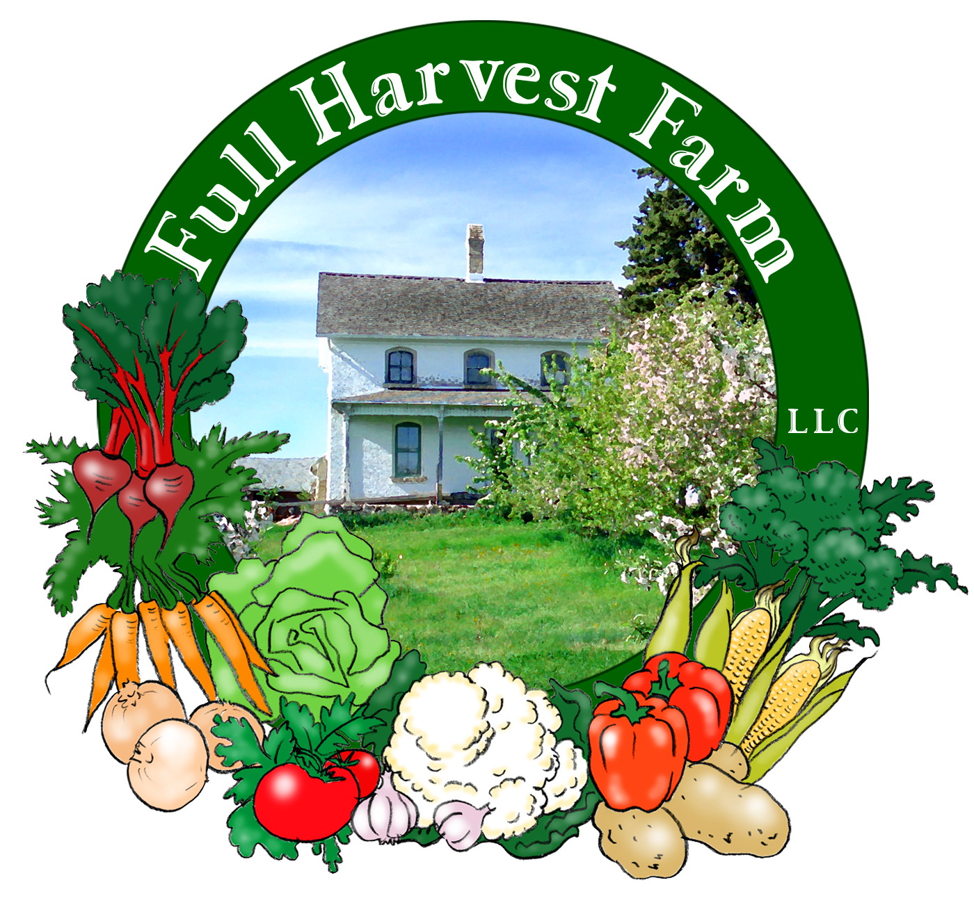
Full Harvest Farm, LLC
7112 County Road S
Hartford, WI 53027
262 673-6760
fullharvestfarm@gmail.com
http://www.fullharvestfarm.com
Box #8
Even Box
21 August 2024
Contents
Dill
Broccoli
Cabbage
Carrots: Orange & Yellow
Cucumber
Garlic
Kale
Lettuce
Pears: Bartlett

New Stuff: nothing this week
Choice Box: pears and ??

The broccoli bed is doing a wonderful job of providing lots of delicious stalks. Looks like it'll keep doing so for another week.
Broccoli Balls
Steam: 4 cups broccoli
-until tender.
Put in a food processor:
1 cup almonds, raw or toasted
-pulse in 1-second bursts until finely ground. Put into large bowl.
Now put the into the food processor:
steamed broccoli
¼ cup fresh basil leaves (or 2 Tbsp. dried basil)
¼ cup fresh parsley leaves
2-3 cloves garlic, peeled
and pulse in 1-second bursts until finely chopped. Transfer to large bowl.
Add: 1/3 cup grated Parmesan cheese
1/8 tsp. cayenne pepper, optional
2 lg. eggs, beaten
½ tsp. kosher salt
freshly ground pepper
Mix all ingredients together thoroughly. Use a scoop to form balls, pressing down firmly to pack mixture into scoop, and space balls out on a sheet pan lined with parchment paper.
Bake in a 350 degree oven for 25 minutes, or until golden brown.
Serve over cooked pasta with your favorite sauce.
Broccoli balls freeze beautifully.

I watched Jacques Pepin make this on his cooking show and thought: "Cabbage? With shrimp? That's an odd combination." It may be odd but it's delicious.
Cabbage with Shrimp serves 4
In a large sauté pan over medium heat, put:
1 cup chicken or vegetable stock
Add: 4-6 cups cabbage, chopped into ¼”x2” pieces
(any kind of green cabbage will work)
2 lg. cloves garlic, chopped coarsely
-Cook for 8-10 minutes, covered.
Add: 1 cup heavy cream
1 Tbsp. Dijon or brown mustard
¼ cup white wine (dry, not sweet)
-Stir and simmer for a few minutes to evaporate the alcohol.
Add: 1 lb. shrimp, shelled completely
salt & pepper to taste
-Stir, cover, and cook just until shrimp are done. Serve as is, over rice or noodles or whatever you like.
NOTE: I would not substitute 2% milk or anything else for the heavy cream in this recipe—the taste is worth the extra calories. And, cream does not curdle when boiled, so you can simmer your shrimp with an easy mind.
I’ve also made this with salmon filets and sea scallops, and it was just as good, altho you might want to increase the brown mustard a little bit.

Lucky you! Chuck decided to dig up some yellow carrots along with the orange, so now you can try them both. There's purple out there somewhere, along with red, but both of those colors grow slower. Dunno why.

The cucumbers were so abundant on Tuesday that we're giving everyone 2. Some trellises are doing a better job of keeping the fruit from being too badly scarred than others--seems to be the angle. The vines are growing well with not much disease. Keep your fingers crossed we have a nice, long cucumber season.

One can not have too many kale recipes. This is a good one.
Kale & Lentils with Tahini Sauce
In a small saucepan, put:
2 cups water
1 cup lentils, picked over and rinsed
¼ tsp. turmeric
¼ tsp. ground coriander
-Cover, bring to a simmer, and cook until the lentils are soft but still retain their shape.
While the lentils are cooking, whisk together in a large bowl:
2 Tbsp. tahini
2 Tbsp. lemon juice or wine vinegar
2 Tbsp. olive oil
¾ tsp. kosher salt
¼ tsp. pepper
When the lentils are done, whisk 2-3 Tbsp. of the remaining water in the pan into the sauce. Drain the lentils and add to the bowl. Toss with sauce.
Into a skillet, put:
¼ cup water
1 bunch kale, washed, center rib removed and sliced into thin strips
-Simmer, covered, for 6-8 minutes, until kale is tenderer but still green—water will probably cook away about the time the kale is done. Add kale to bowl and toss with lentils. Serve.

Chuck picked all the lettuce out of our latest patch on Tuesday. We are now between lettuce beds as we wait for the next one to mature. Likely no lettuce in next week's box, possibly the week after as well.

We grabbed the pole pickers and did our best to find you some pears that are in better shape. They still have a sting or two, a little contortion and so forth, but these are bigger, closer to ripe and generally easier to eat. Leave them on the counter. When the neck gives under gentle pressure, they're ready to eat.

Field Notes
The last rain dropped 1.25", making the ground pretty muddy but the new transplants pretty happy.
We walked around the farm to see how our vegetables are progressing. The peppers are bearing and there are flowers, but none of the fruit are full-sized yet, so we're about 2 weeks or more away from any peppers. The tomatoes are sizing up, some fruit is even starting to turn red: the Juliets, no surprise, since they usually ripen first. There are a few slicing tomatoes that are light green, so red is a week or so away.
We have both fruit and flowers on our eggplants, so a continuous supply of those starting in a week or so. Not sure we'll be able to give them to everyone at first--just have to see how many we get.
Tomatillos are tall and healthy with lots of fruit. The bottom globes are starting to fill up--a week or 2 on tomatillos.
The 2nd patch of zucchini and patty pan squash are finally starting to grow. Once they start, they usually grow quickly, but we're 2-3 weeks out before we can harvest any squash.
We picked a few ears of sweet corn and tasted them--almost ready. Look for sweet corn in your box next week and pray the raccoons raid someone else's field.

Enjoy this cooler weather--looks like it's going to heat up by the weekend. The tomatoes will be happy.

Take care.
Terry & Chuck

