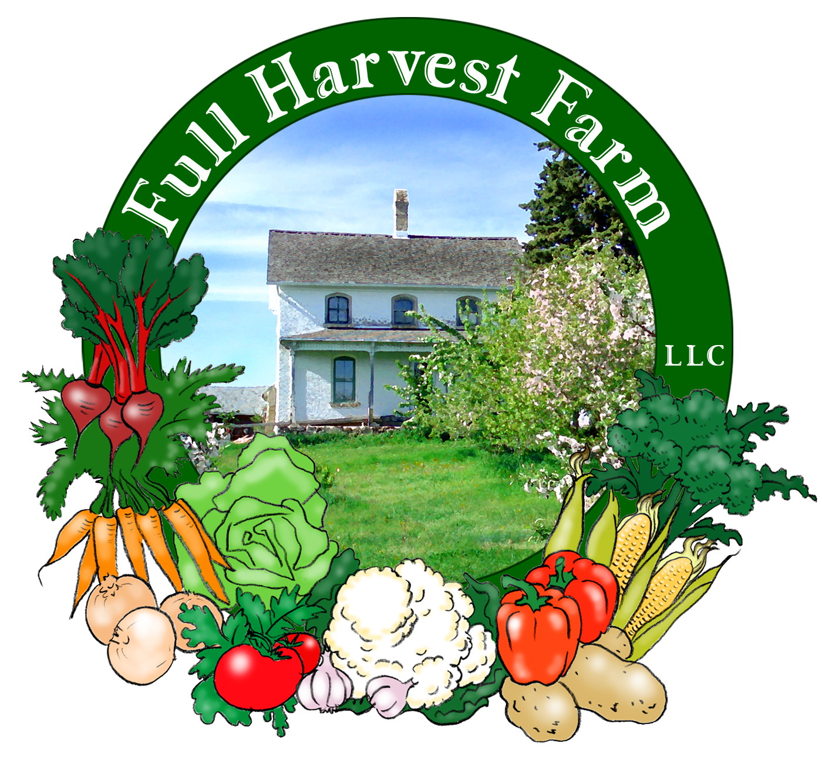
Full Harvest Farm, LLC
7112 County Road S
Hartford, WI 53027
262 673-6760
fullharvestfarm@gmail.com
http://www.fullharvestfarm.com
Box #7
Odd Box
14 August 2024
Contents
Dill
Broccoli
Cabbage
Carrots
Cucumber
Lettuce
Onions
Pears
Potatoes: Red

New Stuff: cabbage, pears
Choice Box: Garden Mix, pears, kale, ??

Cabbage is one of the most widely eaten vegetables in the world. Raw, boiled, pickled or sautéed, we do love our cabbage.
Luckily, it’s low in calories but still contains significant amounts of vitamins A and C, calcium potassium and magnesium. Different kinds of cabbage vary in the amounts of their vitamins and minerals: purple cabbage is higher in vitamin C, while savoy has more vitamin A, calcium, iron and potassium. Traditionally, cabbage is considered a beneficial digestive aid and intestinal cleanser.
Store cabbage in your vegetable drawer, but don’t remove any of the outer leaves unless they’re starting to go bad. You can put it into a plastic bag, or not, it will keep well either way. Uncut, cabbage should store for 3 weeks to 2 months. If you use only part of a head, pare off any discoloration before using the rest.
When properly cooked, cabbage is delicious. One way to do that is to steam wedges for 5-7 minutes, then top with butter, salt and pepper. Go Italian with some grated Parmesan cheese, or be a good Wisconsinite and add grated cheddar. If you overcook cabbage, it turns an ugly gray color and has a sulfur smell.
Chuck planted a small amount of cabbage this year, and took good care of it, cultivating it often to keep the weed pressure down. The heads have gotten dense and hard, and that's when you harvest.
Cabbage is one of the vegetables that actually seems to increase in volume after you cut it. This explains why a smallish head makes so much coleslaw.

Full Harvest Farm Coleslaw
Serves 6-8 as a side dish
Dressing:
½ cup mayonnaise
¼ cup apple cider vinegar
¼ cup dark or light brown sugar
2 Tbsp. brown mustard
1 tsp. dill seed
1 tsp. celery seed
2 tsp. salt
1 tsp. freshly-ground pepper
-Whisk the dressing ingredients together in a large bowl until combined. Whisk the dressing again before adding the vegetables to be sure there are no granules of sugar.
Vegetables:
8 cups shredded green and/or red cabbage, and/or carrots, celeriac, kohlrabi, fennel bulb, radish, rutabaga, turnip, etc.
½ cup onion, minced
-Add to dressing and toss until all the vegetables are dressed. Allow to sit at room temperature for 30 minutes so the flavors meld. Serve. Better the next day.

When we bought our farm in 2002, we got an orchard of approximately 85 trees as part of the deal. In that orchard were 13 pear trees, with the rest apple. Over the years, we planted 2 Ubilene pear trees, some peach and apricot. The original pear trees were a mix of Bartlett, Spartlett, Lincoln and Delicious. Bartlett pears tend to have that classic pear shape: large with a rounded bottom and a defined neck. Spartletts are a little larger. Lincoln is a smaller, shorter, rounder variety with a very short neck. Delicious is shaped like a small Bartlett.
The pears in your box are supposed to be Spartlett, but they are rather small and very green.
Pears ripen best off the tree, at room temperature. A pear is ripe when the stem end yields to gentle pressure. They often lighten in color as well. I put mine in a bowl in my kitchen and check them daily. These pears will take 3-4 days to ripen, approximately, possibly longer. Refrigerating them delays ripening, but not forever.
Because our pears are organic and unsprayed, few will look like the perfect fruit you see in supermarkets. Some will have dimples, or rub marks, or slight insect injury. Dimples are usually plum curculio damage. The insect cuts a curved slit in the pear's skin and lays an egg inside. Pears have a defense mechanism for this invasion: they build a hard wall around the egg, preventing the larvae from eating its way thru the fruit. We have tried to sort out the ones with the worst damage, altho they all have a little.
Since this is the first time we've picked, we may have done so a little too soon, which is why they are rather small and green. Looking over some of the other trees, I see bigger, possibly better looking fruit.
One thing I can say is that our pears, when properly ripe, are delicious. Certainly worth waiting for.

Field Notes
We're looking forward to some rain on Thursday--the fields are a bit too dry.
Chuck has been busy prepping beds for planting our fall crops: broccoli, cauliflower, cabbage, kohlrabi, lettuce, spinach, radishes, white turnips, etc. I see more dill and cilantro in trays, always a good thing.
Chuck has surrounded the sweet corn patch with an electric fence to keep the raccoons out. Fingers crossed it works.
The onion harvest is just about over. Now it's a matter of letting them dry in the sun so they last over the next several months. They'll go from the sun to the greenhouse or the upper part of the barn to continue drying.

I have a revitalizing tip for you that should work for greens like chard, kale, lettuce, as well as broccoli. If you get some that is limp, cut off the bottom, put it in a glass of water (or bowl, if it's large), and leave it there for a few hours. The vegetable pulls in the water and rehydrates itself, looking good as new.

That's it for this week. Stay Cool,
Terry & Chuck

