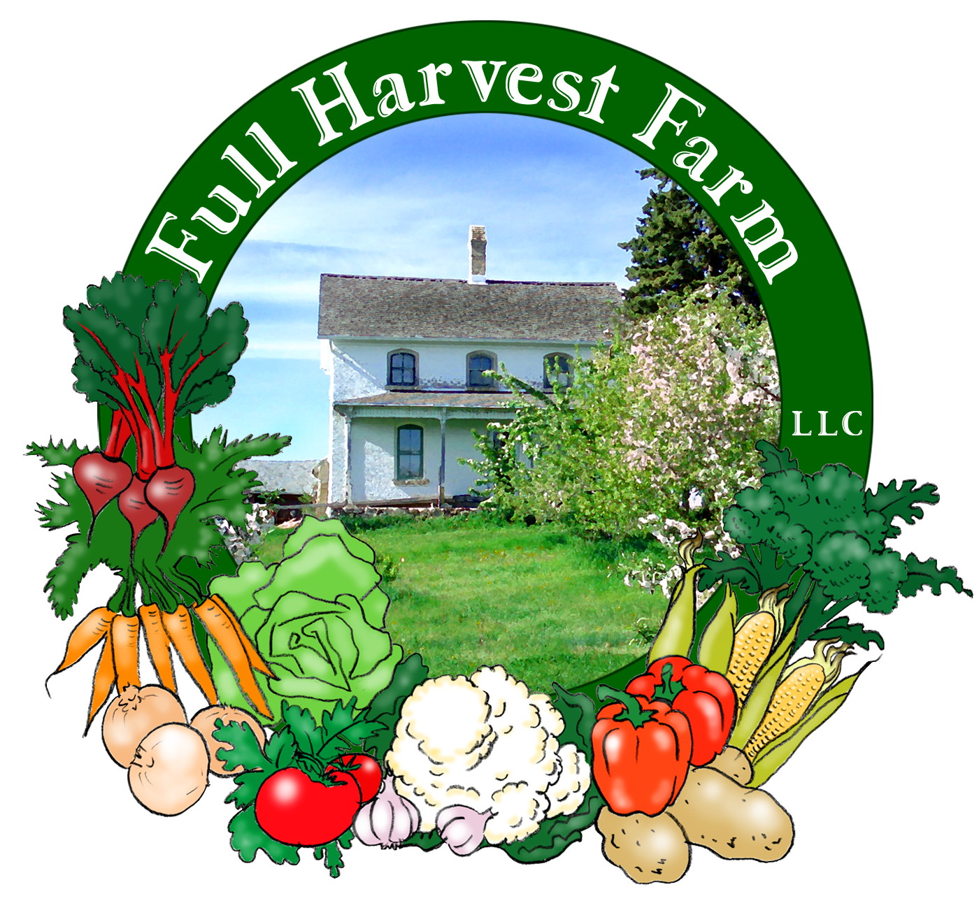
Full Harvest Farm, LLC
7112 County Road S
Hartford, WI 53027
262 673-6760
fullharvestfarm@gmail.com
http://www.fullharvestfarm.com
Box #6
Even Box
7 August 2024
Contents
Parsley
Beans: Green & Yellow
Broccoli
Carrots: Orange
Cucumber
Kale: Green Curly
Kohlrabi: Kossak
Onions: Sweet, Ailsa Craig
Potatoes: Red

New Stuff: carrots, cucumber
Choice Box: beets, greenie potatoes, ??

We are famous for our carrots, so you're in for a real treat!
Best known for their beta carotene, carrots are very high in vitamin A, fiber, calcium, potassium, and contain small amounts of minerals, which are found just under the skin. No need to peel a fresh, garden carrot: the skin is thin and sweet. Simply take your vegetable brush—the one you use to scrub potatoes—and clean the dirt off. Only old carrots need to be peeled, because they've been out of the ground a long time, their skins are drier and can be a little bitter. Also, if the skin shows a grayish color, peel it.
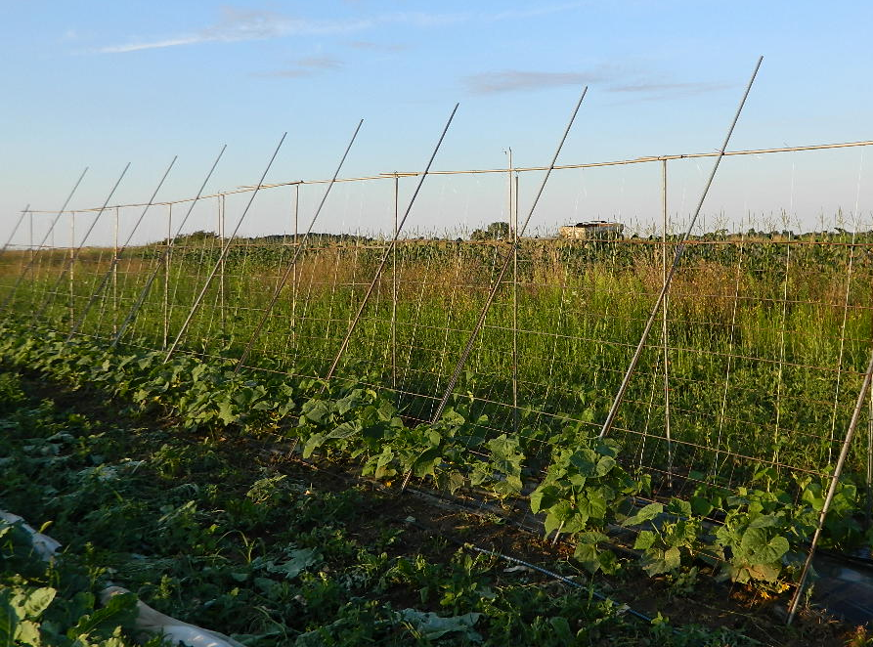
Store carrots inside a plastic bag to keep them from drying out, and put them in your refrigerator. When you get carrots with leaves, break the leaves off and stored separately, or compost them. Carrot leaves are edible and can be put into soups or pesto, but they can be on the bitter side. Carrot roots will keep for months.
You’ll find a range of sizes in your bunch, none of them very large. In future bunches, you may get what we like to call “carrots with character”: double, triple or quadruple roots, lovey-dovey carrots twisted around each other, etc. This is the way they grow in every soil, but farmers sort out the odder shapes and sell only the mono roots to grocery stores. Whether you have a perfectly-shaped mono root or one that looks like it’s running away, they all taste the same. This year, we're growing yellow, purple and orange carrots, altho this week everyone is getting orange. We’re very lucky here at Full Harvest Farm to have the kind of soils that grow great carrots.

Cucumbers are high in vitamin E (probably why they’re so soothing on the eyes), and low in calories. Few vegetables are as satisfying on a hot summer day for replenishing liquids and filling you up.
Storing cucumbers can be tricky as moisture appears to be their enemy. Here’s how I store cucumbers so they won’t get mushy: I DO NOT PUT CUCUMBERS INTO A PLASTIC BAG. I put them in my refrigerator’s vegetable drawer, cut or uncut. They’ll keep for up to a week. I discovered this by mistake one night, when I was too tired to dig up a plastic bag. I tossed a half-used cucumber into my vegetable drawer, letting it fend for itself. 3 days later, I opened my frig to find a cool cucumber whose cut end was only slightly dried out, skin perfect. I was amazed.
I recently read in "Real Simple" about another method that's supposed to work well: wrap a cucumber tightly in plastic wrap, then put the wrapped cucumber in an airtight container (or ziplock bag). They say it should last about a week.
We grow our cucumbers up trellises and mulch them with plastic. We construct our trellises by
pounding in a T-post, then pounding an 8ft., galvanized pipe next to it (the verticals), zip tie them together for strength. The next vertical goes in about 4 ft. further. The horizontal is another galvanized pipe. These pipes are on one side of the planting bed. We place a wire fence section on the other side of the bed, where the cucumber plants are, supported by 2 more galvanized pipes fastened to the horizontal. The idea is to train the cucumber vines up the wire fence so the fruit hangs at an angle. That way, it won't rub against the vine's thorny stems causing the skin to scar. I adopted the original idea from the square-foot gardening book. Chuck thought of the angle adaptation. The advantages are that light and air can circulate much better around a plant supported by a trellis, making it healthier, faster-growing, and less likely to contract powdery mildew, a common fungal disease in gardens. Since much of the fruit hangs above the ground, it's cleaner and easier to pick.
This variety of cucumber is both burpless and "seedless" so the skin is tender and the seeds easy to eat.
The cucumbers we've picked for this box grew pre-trellis and have scars. Simply peel those off.
Creamed Cucumber Salad
In a medium bowl, put:
½ cup sour cream
1 Tbsp. cider vinegar
1 tsp. Kosher salt
1 tsp. sugar
½-1 tsp. pepper
2 Tbsp. fresh dill weed, chopped (or 2 tsp. dried)
1 tsp. brown mustard
-Whisk together long enough to dissolve sugar and salt.
Add: 4 cups cucumbers, sliced however you prefer
½ cup onion, minced
Toss with dressing, then let sit for 30 minutes for flavors to blend.
Adjust this recipe to fit the amount of cucumber you have.
Chuck and I think this may be the last week for green and yellow beans. The plants are slowing down: not pushing out as many flowers. We'll see.
The broccoli plants are producing beautiful heads and lots of them. You'll likely get broccoli next week too.
Green Curly kale can have a strong flavor, which gets milder when cooked. It's especially good made into:
Kale Chips
Preheat oven to 350ºF.
Cut out the stems & center veins of a large bunch of kale. Chop the kale roughly into 1”-1½” pieces, wash and spin them as dry as you can. (You may have to do that step in batches.)
In a large bowl, stir together:
2 Tbsp. olive oil
Kosher salt or sea salt
freshly ground pepper
Toss the kale pieces in the mixture until all are coated.
Line a rimmed baking sheet with aluminum foil or parchment paper. Spread the kale out on the baking sheet as evenly as possible. Bake for 10-15 minutes, or until the leaves are very crispy. They will shrink some. Remove from oven, cool for 10 minutes, and enjoy.
"Kossak" kohlrabi is a variety bred to grow VERY large but still be tender and delicious. It also keeps very well, uncut, in your refrigerator's vegetable drawer. Peel it the same way as I described in newsletter #2.
These red potatoes are still, technically, "new" potatoes so their skins are quite thin--handle them gently. Keep them away from light, so in a brown paper bag where they can breathe, and refrigerated.

Field Notes
Last Thursday's rain gave us 1.5". Things were pretty muddy for a few days. Luckily, Monday night's rain only dropped 1/2", so picking for the box wasn't too slick. We're looking forward to another dry spell to offset the wet.
We did a lot of transplanting for fall on Monday: lettuce, broccoli, cauliflower and cabbage. The lettuce will be ready to cut in 30-40 days, the rest in about 60 days, or early October. Gotta have vegetables for those last boxes.
The tomatoes are growing up! The field crew have already tied 2 rows of Florida Fence and are working on a third. Our old reliable, a large, red grape tomato called "Juliet" is starting to turn color! These are delicious tomatoes with a great tomatoey flavor and little juice. Great for salsa!
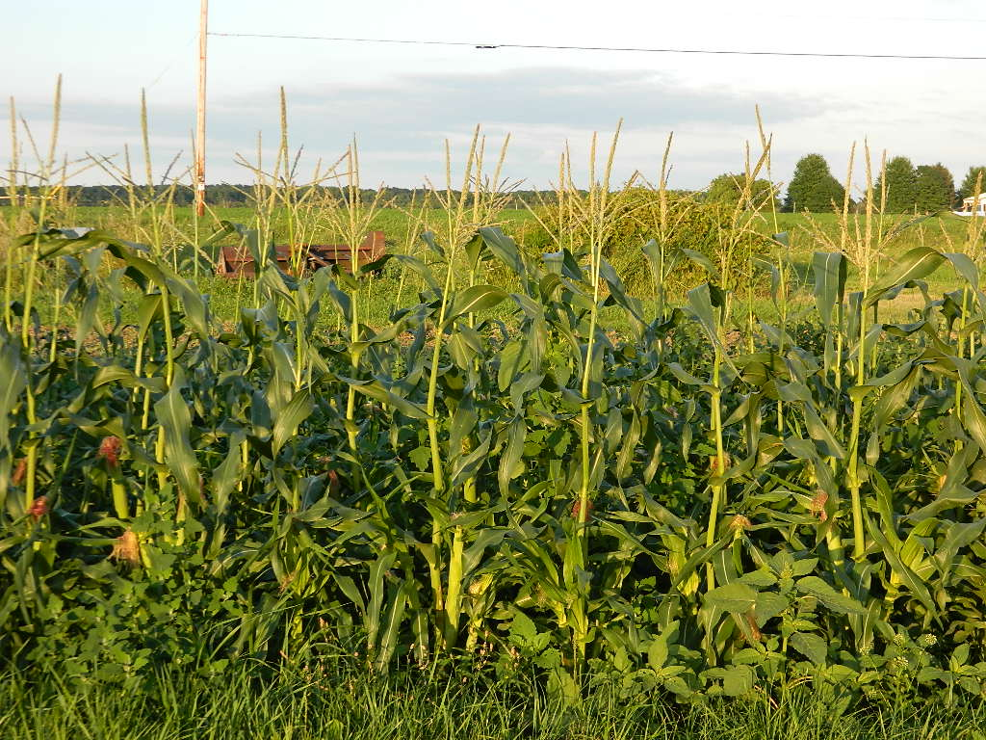
Our first sweet corn patch is almost 5 ft. tall and growing ears with tassels. Chuck will be protecting it with an electric fence so the raccoons don't rip down the ears and take a bite out of each one. They did tremendous damage to our 1st sweet corn patch last year, leaving us very little for the CSA.

A quick reminder: please bring back your wax boxes, and leave them, unfolded, on the stack of wax boxes in the basement of the barn. That stack is located just to the right of the Metro shelf (wire shelving) along the south wall/on your left as you walk towards the cooler.
If you bring a box or bag of your own, you can unload the vegetables into it right away. Then, unfold the wax box and leave it on the stack.
Thank you!
Enjoy this cooler weather.
Terry & Chuck

