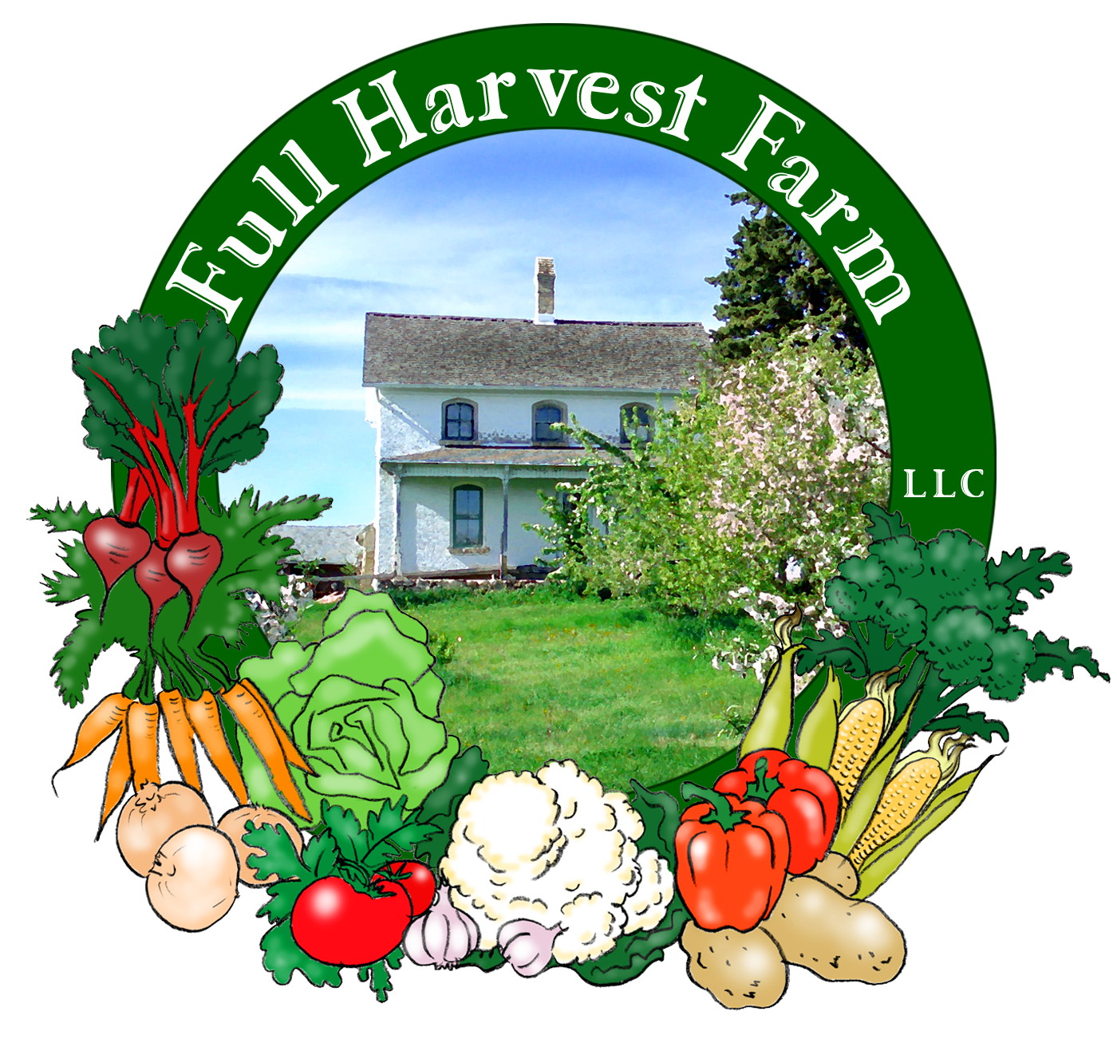
Full Harvest Farm, LLC
7112 County Road S
Hartford, WI 53027
262 673-6760
fullharvestfarm@gmail.com
http://www.fullharvestfarm.com
Box #5
Odd Box
31 July 2024
Contents
Parsley: Mixed Curly & Flat Leaf
Beans: Green & Yellow
Kale: Green Curly and/or Red Russian
Kohlrabi
Lettuce: French Crisp
Onions: Young
Radishes
Potatoes: White Superior

New Stuff: Parsley, kale, radishes
Choice Box: beets, kohlrabi, potatoes, chard

Parsley has often been touted as a breath freshener, but did you know it helps relieve indigestion? That's one of the reasons it's so often used as a garnish in restaurants. Chinese medicine recommends parsley, along with cilantro, to remove heavy metals from the body. It’s also packed with vitamins A, C and plenty of minerals, especially iron.
Chefs generally prefer flat leaf parsley, saying it has better flavor. Frankly, both the curly and flat leaf parsley grown on our farm taste about the same to me.
I leave it to you to decide your preference.

Kale is highly nutritious, loaded with vitamins A, B, C, calcium and many minerals, and has the highest protein content of any cultivated vegetable. It keeps for a long time in the fridge, but you’ll get the most nutrition from it if you use it soon, and eat it raw. Check online for a “green drink” or smoothie incorporating kale.
Raw kale will get tenderer and milder if you toss it with a dressing an hour or 2 before eating. I think the effect is from the vinegar and salt.
Kale will stay hydrated best inside a plastic bag with just a little water on it. To prepare kale, remove most of the center rib (very fibrous), then chop up as your recipe indicates. Depending on the size of the pieces, kale will cook in 10-20 minutes. You want it soft, mostly tender with just a little chew, and still green in color.
The curly green kale tends to be a bit on the bitter side (good for the heart). If a little bitterness is not to your taste, remove that by blanching the leaves in boiling water for 2 minutes, then proceed with whatever recipe you wish. Frost tends to sweeten the taste of kale, or, at least makes it less bitter. In some years, one type of kale will be considerably milder than another, for no discernible reason. Young kale leaves are usually sweeter and milder than older ones.
You may find some leaves with small holes or rips due to insect damage. They do not affect the flavor, but you should use those leaves first.

In 2012, one of our CSA members sent me a salad recipe she made up that used kale plus some other vegetables she either got in her box or bought at her local farmer's market. I changed it a bit:
Kale Market Salad
Serves 2-4.
In a food processor or blender, put:
1/4 cup scallions or onion
1 clove garlic
1/4 teaspoon fine grain sea salt, plus more to taste
2 tablespoons fresh lemon juice
1/3 cup / 80 ml extra virgin olive oil
2 tablespoons ripe avocado, approx.
1 teaspoon honey, or to taste
fresh pepper to taste
-Process until smooth. Taste, and adjust with more salt, or honey, or lemon juice.
Into your salad bowl, put:
salad dressing above
1/2 bunch kale, destemmed, washed, cut/torn into pieces--or use however much you want
-toss the kale with the dressing and leave to marinate for an hour or more. This step both milds and softens the kale. If you don’t have an hour, use your hands to work the dressing into the kale.
Just before serving, add:
1 cup cooked farro, quinoa, millet, rice or other grain
4-5 carrots, very thinly sliced
1 small bulb of fennel, transparently sliced
1 avocado, cut into small cubes
a big handful of almond slices, toasted
Really, put in whatever vegetables you want. Radishes and kohlrabi spring to mind.
-toss, taste, and adjust the seasoning as needed.

The name “radish” is from the Latin radix meaning root. Radishes have been eaten for hundreds of years by the Egyptians, the Romans, the Greeks and on up the ages. Radish roots are mostly water with a few minerals, but the leaves, my goodness, the leaves are an excellent source of vitamins A, C and the B’s. Radishes are often used as blood cleansers and digestive aids. The leaves have a spicy flavor, much like mustard greens. You can eat then raw, but the texture of a fuzzy leaf is not to everyone's taste. Cooking them a bit gets rid of the fuzzy. Flea beetles like radish leaves too, and are the cause of any small holes. The holes do not affect the flavor of the leaf or the root. Wash both thoroughly before eating, and store in the vegetable drawer in the frig.

We cleared out our oldest kohlrabi patch on Tuesday, which was, sadly, buried in the weeds. The harvest was a mixed bag of medium-to-small kohlrabi. The next patch has been better cared for so should be bigger.

Field Notes
We are in the thick of a hot and humid period right now. There have been a few, light showers, so crops in the field are happy. Normally at this time of year, we're in a short-term dry spell until mid to late August. But this year we've had rain often and sometimes more than we need. I'll take this year's glut over last year's drought.
One crop that the wet has not improved is garlic. We planted a lot last year--6 beds--but only harvested 4 because we had to dig it all by hand. Because the harvest took so long and was so wet, the moisture in the soil rotted the outer covering on the remaining garlic bulbs, making them unstorable. A shame, but that's life on a farm.
Potatoes continue looking great. The first beds are drying down, which is just what they're supposed to do. The potatoes under their hills will keep until we decide to dig them up, when their skins will be tougher.
The next broccoli patch is producing heads. If we have enough, we'll put them in next week's box.
We've been tying up our tomatoes so they'll get more sun and be easier to pick. Baling twine secured to T-posts is woven between the plants in successive heights as the plants grow bigger. We top out at about 5 ft., altho some tomatoes will get bigger and flop over the top string heading back to earth.
Another crop we'll be stringing up is cucumber. We're trying a slightly different trellising method this year that should let the fruits hang without rubbing against the thorny stems. I'll put a picture in the next newsletter.
And that's it for this week.
Stay Cool!
Terry & Chuck

