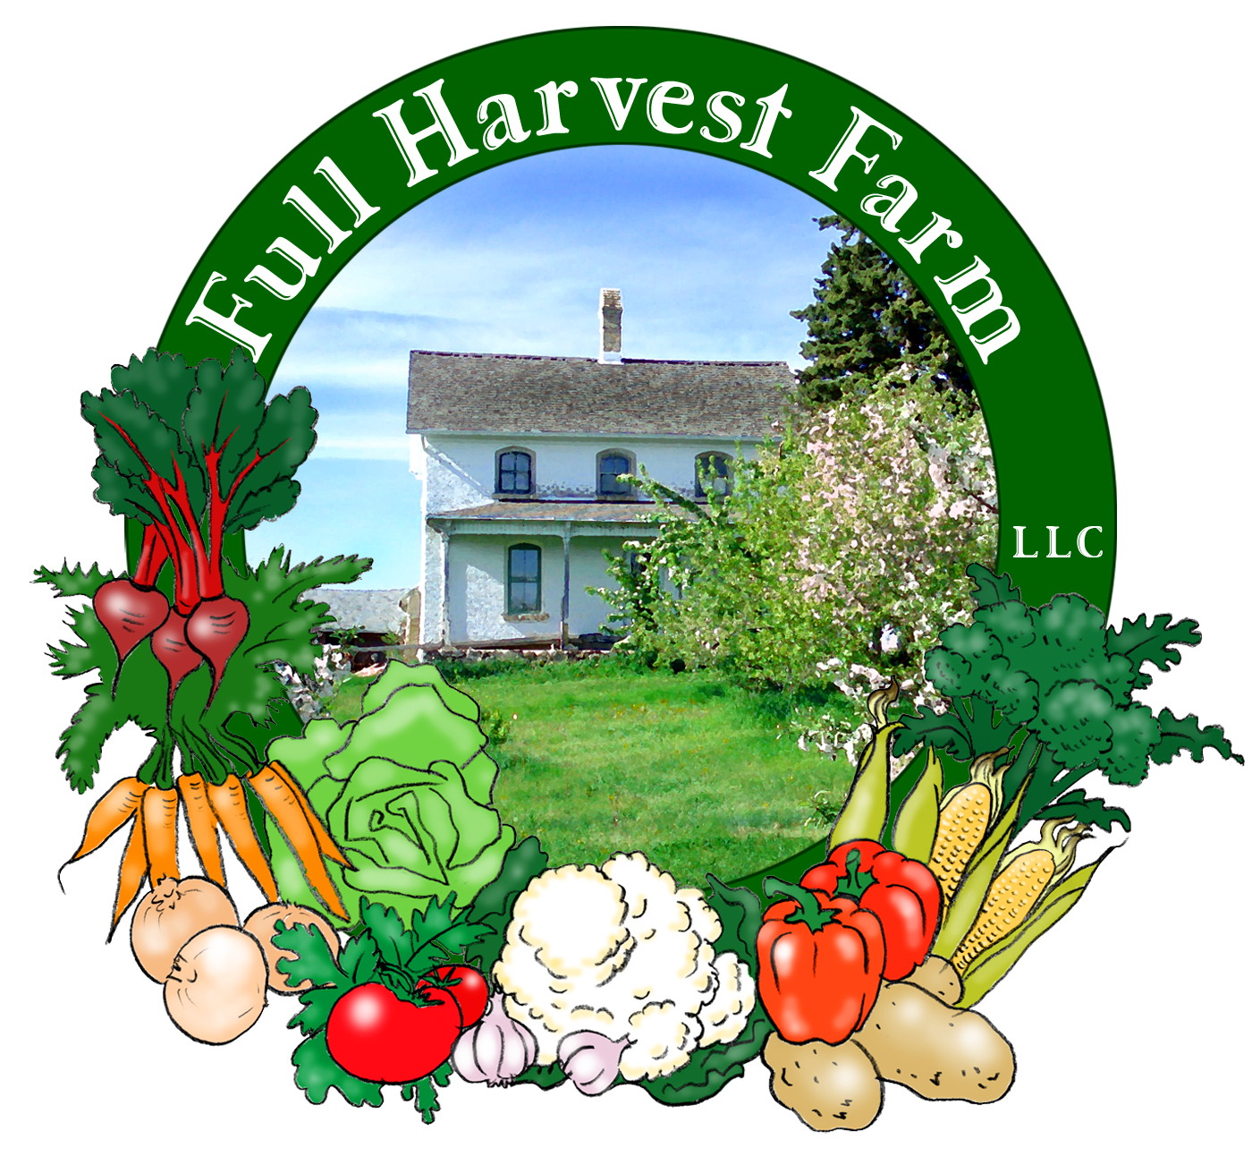
Full Harvest Farm, LLC
7112 County Road S
Hartford, WI 53027
262 673-6760
fullharvestfarm@gmail.com
http://www.fullharvestfarm.com
Box #4
Even Box
24 July 2024
Contents
Basil
Beans: Mixed, Mostly Green & Yellow
Beets: Red
Chard
Fennel
Garlic: Georgia Crystal
Lettuce: Green Leaf
Potatoes: New White Superior

New Stuff: potatoes
Choice Box: damaged beets, flowers

Potatoes are one of the leading vegetables grown worldwide. They come in all shapes, sizes and colors, and thrive in areas below sea level, and those 14,000 feet above. Native to the Andean mountains of South America, they were brought to Europe by the Spaniards.
Potatoes are an excellent source of complex carbohydrates and minerals, especially potassium, providing you eat the skin since most of these nutrients are in or near the peel. Because you're getting organic potatoes, you don't have to worry about anything sprayed on them to prevent sprouting or greening.
Your potatoes have been washed minimally and may have some soil on them. Since these are new potatoes, they have thin skins that are easily torn. To wash, cup a few in your hands under running water, and rub them lightly together. If you have a very soft brush and use it very gently, you may keep most of the skin intact.
Altho we sort thru our potatoes when we bag them, you may find one we missed with a green spot. This is due to exposure to sunlight: potatoes trying to make chlorophyll (so keep them away from sunlight, or any strong light). The green spot will taste bitter, so cut that off.
To keep potatoes fresh for the longest time, store them someplace that's between 45-55 degrees and has rather high humidity. Since few of us have such a specialized place, storing them in the refrigerator is a good choice. There is some research that says refrigerator storage encourages some of the starch to change to sugar resulting in browner potatoes when you bake or fry them. That doesn't sound so bad to me. There is some research that says onions and potatoes should not be stored close to each other or they spoil faster. Let me know if you find this to be true. My mother always stored them on stacking shelves in our basement, and they both kept a long time.
Roast potatoes using the same method we recommend for beets.
Chuck and I have two kinds of potatoes in the ground this year: Red Norland, a red-skinned, white-fleshed potato, and Superior, a white-skinned, white-fleshed potato. Superior is in the russet family, makes a good baking potato. The reds are more in the "waxy" style, supposed to be good for potato salad. You'll get them in upcoming boxes.

Parsley Potatoes
Wash the potatoes (you decide how many) and cut so that all pieces are about the same size. Steam them until they are fork-tender but still holding together. While the potatoes are cooking, chop enough parsley to make ¼ cup. When the potatoes are done, drain off the water, remove the steamer (a pair of tongs works well), leaving the potatoes in the pot. Add 2 Tbsp. butter to the pot. Cover and let sit until the butter melts (1-2 minutes), then add the chopped parsley, salt and freshly-ground pepper. Toss gently so the butter and parsley are evenly distributed. My mother made this dish a lot, not only because it’s easy, she felt it was also elegant.

Asian-Style Chard
Wash chard and cut out stems. Grouping several stems together, cut into 1" lengths and set aside.
Pile leaves together, and chop roughly.
In a large skillet over medium-high heat, put:
1 Tbsp. oil
-and heat until it shimmers. Add stems, toss and cook 1-2 minutes.
Put in: chard leaves
2 garlic cloves, minced
-cook until leaves begin to wilt, 2-3 minutes.
Stir in: 1 Tbsp. soy sauce
2 Tbsp. hoisin sauce
-stir and cook until chard is tender, 2-3 more minutes.
Add: freshly-ground pepper to taste
Serve immediately.

If you decide to roast potatoes and beets, throw your fennel bulb in too. Cut it up into approximately the same size as the rest.
Or you can make this--another recipe that only needs one bulb of fennel:
Fennel Tapenade
Puree in blender or food processor:
1/2 cup pitted kalamata olives
1 fennel bulb
1 clove garlic, chopped—or scapes
1 Tbsp. red wine vinegar
2 Tbsp. red onion, chopped
1-2 Tbsp. olive oil (or flaxseed oil)
Taste and adjust seasoning and oil as you prefer.
Spread tapenade on bread, toast or crackers as an hors d’oeuvres, or on sandwiches like mayonnaise.

We dug this fresh garlic last week from the hardneck beds (the kind that forms scapes). Because it is recently out of the ground, the covering over each clove may be a bit thicker than you're used to. That thins to the paper-like layers over time. New garlic is a little milder in flavor than garlic that has dried. If you don’t use it right away, leave the garlic out on your counter to continue drying.
This variety is called "Georgia Crystal". It's a white garlic with medium flavor, good raw or cooked. Georgia Crystal tends to lose a lot of flavor when you roast it, altho it still has that lovely, buttery texture.
Raw garlic is believed to be helpful in fighting infections, as an expectorant and decongestant, a reducer of blood pressure, cholesterol and triglycerides. Unfortunately, consuming raw garlic usually gives you “garlic breath” and can also scent your skin. Chewing some raw parsley may help, and taking a shower certainly does. It always fades over time--but only if you stop eating a lot of it.

Field Notes
We've enjoyed this dry spell, especially as we're deep in the garlic harvest. Mid-July is the time to harvest the garlic we planted last November. The leaves have dried around halfway down, and the bulbs are about as big as they are going to get. Usually, the soil is dry this time of year and the bulbs are easy to pull out of the ground once we've undercut the beds. This year, the soil in that field was still damp and the bulbs were stuck in it. Using the tractor with the undercutting attachment did not work. So, we had to dig it by hand. So far, we've finished 4 beds out of 6. That's 4-200 ft. long beds containing 4 rows of garlic per bed. Yep.
Because we had that nice dry spell, we could leave the garlic outside to dry in the sun for a day. What dirt still clung to the roots dried and was easy to get off. Drying garlic in the sun helps kill fungus and bacteria that causes mold and rot while garlic cures. It's next trip is to the upstairs of our barn where Chuck hangs it in small bunches, or lets it continue to dry in shallow plastic trays set on wire racks. Our barn (built in 1883) was constructed with 1" gaps between its vertical boards to let the wind blow thru. We think because the family who owned it before us (around 1913), stored their hay loose rather than in bales.
Chuck dug up carrots from several parts of our carrot field, but found them on the small side, so we're waiting another week before we dig more. Cross your fingers for next week.
The broccoli plants look nice and big, but are not yet forming heads. Shouldn't be too long now.
We've got some cauliflower to tie: trying to keep the heads as white as possible. Looks like a few more weeks on this one.

Apparently, our website designer started working on our website on Monday, but never let me know. Right now, 7-23 at 9:14pm, the site is working. But will it be tomorrow or the next day? Early Tuesday afternoon I wrote this: "No luck getting ahold of our website designer, to fix our stuck website". Just to be sure you get it, I'll be emailing the newsletter as an attachment again this week. I'll also print several and leave them next to the Signin Sheet near the cooler door.

Have a great week!
Cheers,
Terry & Chuck

