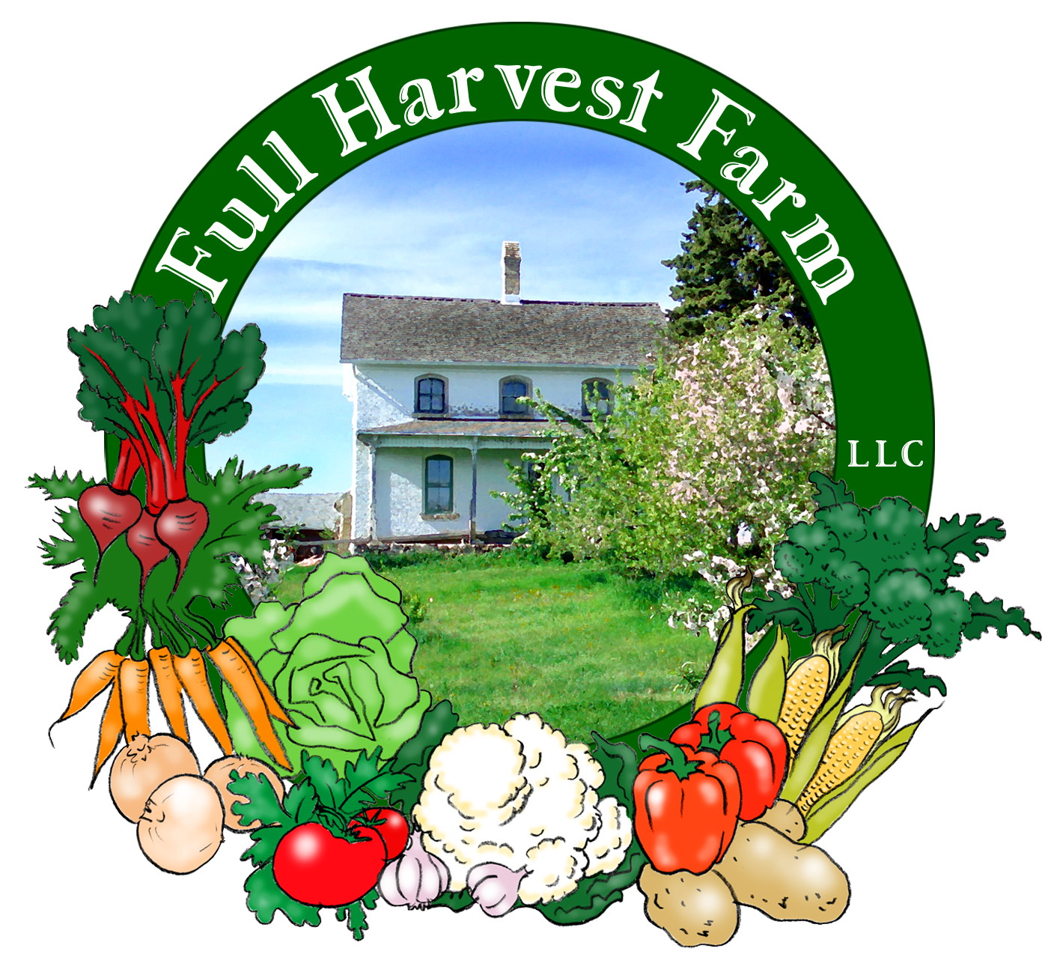
Full Harvest Farm, LLC
7112 County Road S
Hartford, WI 53027
262 673-6760
fullharvestfarm@gmail.com
http://www.fullharvestfarm.com
Box #3
Odd Box
17 July 2024
Contents
Basil
Beans: Mixed Types
Beets: Orange
Broccoli: Couple Boxes
Broccoli or Cauliflower: Family Boxes
Fennel
Garlic: Green
Garlic Scapes
Lettuce: French Crisp, Green Romaine

New Stuff: broccoli, cauliflower, fennel
Choice Box: flowers

Broccoli is loaded with vitamins A, C, calcium, potassium and iron. To enjoy most of its nutritional value tho, eat broccoli raw. Or, gently cook or steam broccoli just until bright green and al dente. It’s best stored inside a plastic bag in your refrigerator. Broccoli should keep for about a week. You may find a green cabbage worm or two in your broccoli. They don’t bite, and are easy to remove. Check for them underneath the florets as you wash or cut broccoli up, and deposit them in your compost container if you find any. Because we’re organic, we do not spray for cabbage worms unless there is a large infestation, and there isn’t. I imagine the killdeer and barn swallows find them quite a tasty treat.
Broccoli florets are aptly named: they are flower buds. If left to bloom, the buds open up into bright, yellow flowers—edible flowers. The younger a head of broccoli is, the smaller the buds. We try to harvest them when the buds are around 1/16". Sometimes, the buds don't mature evenly and you'll see larger and smaller buds on one head.
The first broccoli patch is producing almost enough to give most folks some. These first heads are often small, and irregularly shaped, but I've never found that an unusual shape affects the flavor. Never fear, there's another patch in the works. When that one is ready, broccoli will show up for a few weeks in a row, at least, then again when the next patch is producing.
The early cauliflower is also small, which might be because it was rather buried in weeds. We've harvested just enough broccoli to give it to the Couple boxes, and cauliflower goes to the Family Shares, with just enough broccoli to even out amounts.
Depending on the heat and moisture, broccoli can have a sharp taste. Cooking it gets rid of that sharpness, even if it's 2 minutes in boiling water.

Cauliflower has no saturated fat, is low in cholesterol, high in dietary fiber, vegetable protein, vitamins C, K and B6 as well as many minerals. Research has found that regularly eating cruciferous vegetables (broccoli, cabbage, cauliflower, Brussels sprouts, etc.) may lower your overall risk of cancer. (Broccoli, cauliflower, Brussels sprouts and olives have the highest concentration of plant sterols that can lower serum cholesterol.)
Like broccoli, a head of cauliflower is a collection of small flower buds. If left to mature, small, yellow flowers bloom all over the head.
Store cauliflower in the refrigerator, inside a plastic bag. It should keep for a week or 2. The sprayer on your sink does a great job of blasting off dirt and other debris.

Fennel is a popular vegetable in Europe for its unique taste and ability to pair well with many other flavors.
Fennel has been used for hundreds of years as an aid to digestion. It’s high in vitamin A, calcium, potassium and iron. The bulb and leaves have a mild, black-licorice flavor that is very good in salads, especially coleslaw, vegetable dishes and with fish. The frugal cook likes it because all of fennel is edible: bulb, stalks and leaves. To use, cut off the top of the root from the bulb, which is tough, and chop off the leafy stalks for use later. Wash the bulb under cold, running water to get out any dirt that may have sifted down between the layers. Place the bulb flat on your cutting board and slice it in half. Set the cut side down on your board and slice lengthwise.
Use the feathery leaves as a fresh herb. They lose some flavor each day, so go thru them as quick as you can. Or, add them to your next batch of pesto, or potato salad. You can dry fennel leaves on paper towels in your microwave. Store the dried, chopped leaves with your other herbs. If you make stock, the fibrous stalks are an excellent flavoring. One of our site managers cuts the stalks into 4” lengths and stores them in a jar of water in her fridge: it’s one of her children’s favorite snacks. Like sugar cane, they chew on the stalks to get all the tasty, tender bits, then spit out the fibrous part.
Making an infusion (think tea) is a way to use a small amount of something, and get good flavor out of it. Here’s how you can do that with your fennel:

Fennel with Fish
Clean the fennel as described above, reserving some fronds to add later. In a 10” sauté pan, over medium heat, add:
2 Tbsp. butter
2 Tbsp. olive oil
1-2 fennel bulbs, cleaned and sliced thinly
- sauté just until the fennel begins to brown.
Add: ½ cup water, stock or dry white wine
-add the stalks, cut into 4” lengths (so you can remove them later), cover the pan, turn the heat to low, and cook the fennel until it is completely soft, about 15 minutes. While the fennel cooks slowly and flavors the liquid, snip off the rest of the leaves and chop them up. When the fennel is done, push the pieces toward the sides. You should have a thin layer of fennel-infused liquid on the bottom of the pan. If you don’t, add more water, stock or wine. Scrape the bottom of the pan to loosen any stuck-on bits (this is called “de-glazing”). Add enough fish to fill up the area inside the cooked ring of fennel, season with salt, freshly ground pepper, and half of the chopped fennel leaves if you intend to turn the fish over. If you’re using thin fillets, like Tilapia, you won’t need to turn them over, so sprinkle all of the chopped fennel over the top. Cover the pan again, and simmer slowly, just until the fish is no longer transparent in the middle, but is still moist. The length of time will depend on the thickness of the fish. The best rule I’ve found is the simplest: Measure the fish at its thickest point, and cook it 10 minutes per inch, regardless of the cooking method. The fennel bulb is tender and delicious, but the stalk will be too fibrous for eating, so remove the stalks before serving.

First basil bunches this week! You're not going to have enough basil to make the following recipe from the bunch in your box, but you can cut it in half, or make up the difference with other fresh herbs: parsley, fennel, oregano, rosemary, tarragon--whatever you have. And, you can substitute a bunch of your garlic scapes for the garlic cloves.
Basil Pesto
makes approx. 2 cups pesto
In the bowl of a food processor, put:
2 cups, packed, fresh basil leaves, washed and spun/dried
4 medium cloves garlic, chopped coarsely
1/2 cup extra-virgin olive oil
1/2 tsp. salt
1/2 tsp. freshly-ground pepper
1/4 cup almonds, walnuts, pine nuts, etc.
1/4 cup grated Parmesan cheese
Process all ingredients just until uniform in size. Add more salt, pepper, etc. to suit your taste. You can also freeze this pesto, altho the flavor and texture are better if you leave out the cheese.
Pesto is a pretty potent sauce on pasta, so use sparingly. Start with about 1 Tbsp. per serving, taste, then increase the amount, if desired.
Pesto can be frozen easily. I buy a package of the ½ cup containers and put the finished paste in those. To thaw, take a container out of the freezer the night before and put it into your refrigerator. Do NOT try to thaw it in the microwave: it’ll turn black. Basil oxidizes easily, so always cover it when you’re not actually spooning some out. If you can, pour a thin film of olive oil over the top of the paste to protect it from the air.
“Pesto” simply means “paste”. You can make pesto with other herbs besides basil. People often substitute parsley when they’re a bit short on basil for this recipe. I’ve made delicious herb pestos using tarragon, thyme, parsley, fennel, sage, lovage, oregano, rosemary, marjoram, Summer savory and sorrel. Use one quarter to half as much of the stronger herbs: sage, rosemary and lovage.

Field Notes
Saturday night's surprise storm dropped 1.5" of rain on us. Perfect timing as Chuck was working on running water out to one of our far West fields to irrigate some lettuce we'd just planted. But we're ready is we have another dry spell.
The potatoes are flowering! This is a sign that the roots are starting to swell, which is what a potato is. Chuck is keeping an eye out for Colorado potato beetles, in case the population gets too large. If it does, he sprays an organic insecticide with spinosid in it. When the beetles eat the leaves, they die.
We have a few beds of broccoli that are growing well and should produce larger heads in a few weeks.
The cauliflower is twisting its inner leaves, indicating that it's starting to form a head. When the head gets to tennis ball size, we'll tie the leaves together so sunlight won't reach the head, keeping it nice and white.
And that's it for this week. Enjoy the slightly cooler and less humid weather.
Stay Cool,
Terry & Chuck

