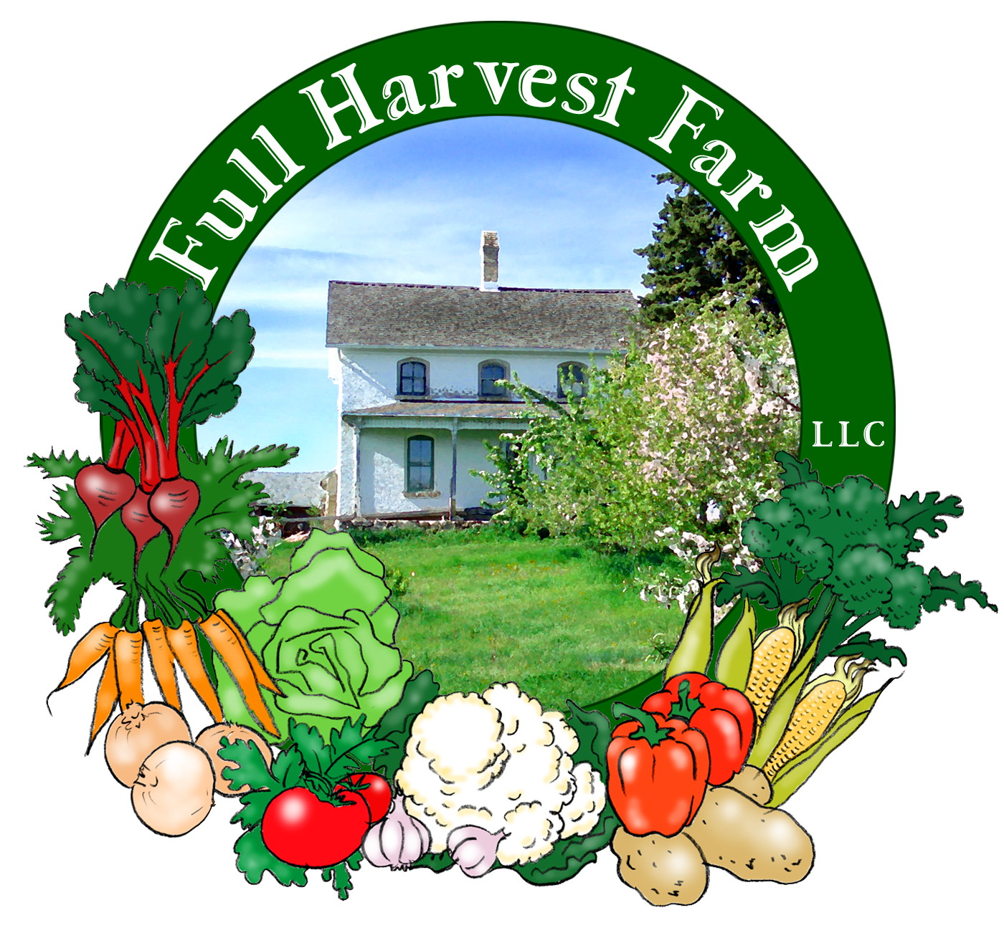
Full Harvest Farm, LLC
7112 County Road S
Hartford, WI 53027
262 673-6760
fullharvestfarm@gmail.com
http://www.fullharvestfarm.com
Box #2
Even Box
10 July 2024
Contents
Parsley Plant: Flat Leaf
Beans: Green, Purple, Yellow
Beets: Red
Garlic Scapes
Kohlrabi
Lettuce: Romaine
Onions: Knob
Zucchini / Patty Pan Squash

New Stuff: parsley plant, beans, kohlrabi
Choice Box: zucchini, extra nasturtiums

Parsley prefers full sun. Plant this in the ground or a pot and give it a little fertilizer and plenty of water to start out. In 2-3 weeks, after it’s adapted to its new home and put down extensive roots, the plant will produce nice, long, green stems with tasty, green leaves you can use in your kitchen. Pick the biggest stems with the most mature leaves to encourage the plant to keep growing.
Parsley is a biennial. This means it flowers the 2nd year of its life span. If anyone has had a parsley plant survive the winter outside, you probably noticed it started to flower very quickly, in late spring or early summer.
You're getting Italian flat leaf parsley this week.
Green beans contain vitamins A, B₁, B₂, calcium and potassium. Interesting note: fresh beans are not as high in protein as dried beans.
Along with the green beans, Chuck planted yellow and purple beans. The purple are an experiment as we've never planted that color before. Let us know how you like them.
Terry’s Favorite Way To Cook Any Vegetable is an excellent way to cook beans (just under the Couscous with Kohlrabi recipe). Wash them, snap off the stem end then proceed with your recipe. A friend once showed me how much quicker it is to simply break a green bean into smaller chunks than it was to use a knife. Another method is to roast them. Use the Roasted Beets recipe in newsletter #1 as a guide and check them after 10 minutes (or sooner).
Store your beans in the plastic bag they come in in your refrigerator, and use them soon.
Roasted Green Bean Salad
Turn your oven on to 425 degrees.
Using a half-sheet or jellyroll pan lined with aluminum foil (something with sides), roast: 1 cup walnuts
-just until they’re a little browner, about 5 minutes. Set them on a rack to cool a bit. While the walnuts are browning, rinse a pound of green beans (or whatever you have), snap off the stem end and spread them out on a dishcloth to dry.
In a large bowl put: 1 Tbsp. olive oil
Put green beans into bowl and toss with oil until all beans are thinly coated. Transfer the walnuts to a plate to cool and spread the beans out on the half-sheet or jellyroll pan in a single layer. Roast on the top shelf about 15-20 minutes, stirring once or twice, but check them after 10 minutes.
While the beans are roasting, whisk together in a large bowl:
3 Tbsp. Extra-Virgin olive oil
1 Tbsp. balsamic or sherry vinegar
1 tsp. minced garlic (more if you like)
½ tsp. dried thyme
salt & freshly ground pepper to taste
When the beans are done, put them in the bowl and toss: while hot, they’ll absorb more of the flavor of the dressing. Allow green bean mixture to cool some.
To the cooler green beans, add:
1 cup tomatoes, cut into ½” dice
2 Tbsp. chives, chopped
½ cup Parmesan cheese, coarsely grated (or shaved with a vegetable peeler)
2 Tbsp. fresh basil, thinly sliced (or ½ tsp. dried)
Toss together, add toasted walnuts and toss again.
In our neck of the woods, kohlrabi is a favorite vegetable. When I ask my West Bend Farmer's Market customers how they like to eat it, they say, "Raw, with a little salt."
Kohlrabi has a juicy, mild flavor, and is excellent eaten raw. If you’ve eaten broccoli stems, you’ll find kohlrabi similar in flavor, which makes sense once you know they are close relatives and share the same botanical name brassica oleracea.
The name "kohlrabi" derives from kohl, German for "cabbage" and rabi, meaning "turnip". Many botanists believe kohlrabi was bred from both plants. The bulb is actually a swollen section of the plant's stem, which is why the leaves radiate from it.
Nutritionally, kohlrabi contains large amounts of vitamins A and C as well as minerals potassium and calcium. High in fiber, kohlrabi has only 40 calories per cup.
To use it, cut off the outer layer with a paring knife. Start by cutting off the bottom: you’ll see a ring of small, white “hairs”. Cut just inside the hairs with your paring knife, underneath the kohlrabi’s skin and work your way around it like you would peel an apple. With the skin removed, slice it any way you like. I favor julienned pieces in a salad. It’s great shredded and added to coleslaw, or in chunks on a veggie and dip tray. Store kohlrabi in a plastic bag and put in your frig to keep from drying out. It’ll keep for several weeks, unpeeled.
Couscous with Kohlrabi & Chermoula Dressing
Makes 6 servings.
In a small saucepan, put:
1 cup water or stock
-cover, and bring to a boil.
Add: 1 cup couscous
Cover, turn off heat and let sit for 5 minutes. Uncover, fluff with a fork and put into a large serving bowl.
In small bowl, put:
1-2 tsp. minced garlic
2 Tbsp. minced cilantro
2 Tbsp. minced fresh parsley
1 tsp. paprika
½ tsp. ground cumin
1 tsp. Kosher salt
-mash these together with a fork, or put into a mini-chopper and process until combined.
Add: 3 Tbsp. fresh lemon juice
3 Tbsp. olive oil
Whisk together, then pour over couscous. Mix.
Add: 2 cups peeled, diced kohlrabi
½ cup diced radishes
16 olives (kalamata are recommended)
½ cup crumbled feta cheese
Toss gently, and serve.
And now it's time for Terry’s Favorite Way To Cook Any Vegetable: Get out a 9”-10” skillet with a lid. Put it on a low flame and add 2 Tbsp. butter. Add the vegetable(s) you want to the skillet, some salt and freshly-ground pepper. Stir, cover and cook until you reach the desired doneness, stirring a few times along the way.
I think this simple method brings out the purest flavor of the vegetable you’re cooking. When you know what something really tastes like, you can make better choices when combining it with other vegetables.
You can always use another beet recipe. The original here is from a book called “Cooking for Madam” by Marta Sgubin, who was nanny to Jacqueline Kennedy Onassis’s children, and later cook and companion to Jackie. Marta wrote this salad was a huge favorite of Ted Kennedy’s.
Red Beet Salad
Vinaigrette: whisk together:
1 tsp. dry mustard
1 ½ tsp. Dijon or other brown mustard
¼ cup balsamic vinegar
salt and freshly-ground pepper to taste
Now whisk in: ¾ cup olive oil
This makes enough for 2-3 salads.
Scrub 3-4 beets, cutting off the tops and root, and trimming off the brown skin around the top. Slice beets into julienne sticks and sauté on low heat, covered, in a few tablespoons of olive oil. When beets are folk-tender, dump the contents of the pan into a bowl, pour some of the vinaigrette dressing over them and sprinkle with salt and pepper. Toss to coat and allow beets to cool. Vegetables absorb much more flavoring when they’re hot or warm than they do when they’re cold.
Now add: ½ cup chopped parsley or cilantro
Toss to distribute the parsley. Serve now or chill for later.
The first planting of zucchini and patty pan squash has become infected with viruses, so this will be the last for awhile. There are more plants ready to go into the ground in a new place, so we plan to have more in about a month.

Field Notes
We got another 2" of rain since last week, and are very happy it wasn't more. Fingers crossed we have a dry spell for awhile.
Chuck and I were busy on July 4th: we did lots of transplanting. Tomatoes, peppers, eggplant and tomatillos went into the ground along with melons, cucumbers and lettuce. We finished just as some rain moved in.
Where the weeds have gotten ahead of us, we mowed, pulled and cut. The plants should be a lot happier now.
Without the tall weeds, we can see what we have in those spots. Chuck and I discovered kohlrabi that was ready to be picked, and a few, early heads of broccoli. We hope to be able to put broccoli in next week's box, fingers crossed.
The orange beets are getting bigger, and will soon be plentiful enough to harvest for your boxes. We're keeping an eye on some fennel that's sizing nicely, so look forward to that one in the next week or two.
Chuck has been anxiously watching the carrots, and dug some up. Nothing bigger than a little finger yet. Give it a few weeks.

Chuck and I hope you all had a lovely 4th of July.
Here's to a week with very little rain!
Take Care,
Terry & Chuck

