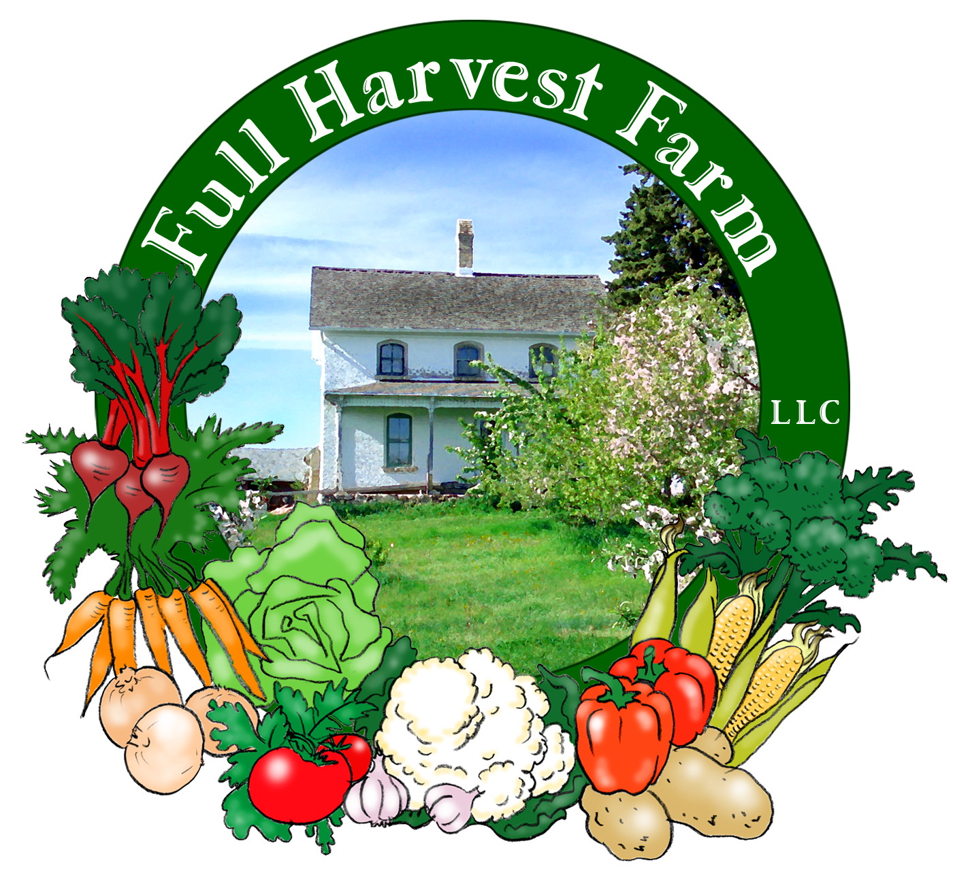
Full Harvest Farm, LLC
7112 County Road S
Hartford, WI 53027
262 673-6760
fullharvestfarm@gmail.com
http://www.fullharvestfarm.com
Box #1
Odd Box
3 July 2024
Contents
Nasturtium 4-pack
Cilantro
Beets: Red
Chard
Garlic Scapes
Lettuce: Green Romaine
Onions: Knob
Sugar Snap Peas
Zucchini

Choice Box: ??
Because this is the first box of the season, everything in it is new and new items are always explained: what it is, what it's good for, some historical information plus nutritional and storage details, followed by a recipe. So this newsletter is twice as long as they usually are. And off we go . . .
Nasturtiums are a flower I’ve grown and loved for years. The flowers have intense, vibrant colors that seem to glow from within, the leaves are round and green with cream markings. But the best part is: it’s all edible. Flowers, stems and leaves have a spicy, peppery flavor that makes your mouth say “Wow!” This cultivar, Alaska, grows to about 6”-8” high and spreads 8"-10" wide. The seeds were a mix of colors: yellow, orange, salmon and red. We've given you a 4-pack. Plant them in sun to part sun, keep watered and fertilize now and again. Your nasturtiums will reward you with lots of beautiful blooms that you can pick for bouquets, use as an edible garnish, or in salads for a gorgeous look and peppery kick. What color will your flowers be?
Cilantro, also called Chinese parsley, is a plant native to southern Europe all the way to India. It's used in many cuisines, particularly Asian and Mexican. Americans have come to love it also. There’s nothing like chopped cilantro in a good bowl of salsa.
In Chinese medicine, cilantro is one of the herbs, along with parsley, that helps cleanse the body of heavy metals. Coriander is the name common to cilantro's round seeds and is a staple in the spice cupboard of Indian cooks.
Cilantro is the fruit fly of the herb world. Once it comes up, you can harvest for about 2-3 weeks before it flowers and goes to seed. To keep a continuous supply in your garden, plant it about every 3 weeks.
Cilantro grows close to the ground, so, altho we've given it an initial dunk, wash it again before using.
One method of storing cilantro is to wrap it in a damp paper towel, put in a plastic bag in your frig. Another is to clip the bottoms, stand the bunch in a glass with an inch of water, change the water every 2 days and keep in the frig. Cilantro will last about a week, properly stored. To keep it long-term, freeze the cleaned leaves in a zip-lock bag, and don’t thaw them prior to using. Altho most herbs taste more intense when they’re dried, cilantro loses flavor when dehydrated, tasting nothing like the fresh version.
This will be the only
Walnut Gremolata
In a food processor put:
1 cup toasted walnuts (can use other kinds)
1 cup parsley, cilantro, or other green herbs, washed
1/4 cup fresh mint, optional
2 tsp. grated lemon zest
1 Tbsp. fresh lemon juice
1 garlic clove, OR several garlic scapes
1/2 tsp. Kosher salt
1/2 tsp. black pepper
olive oil, as much as you prefer
Process until all ingredients are finely chopped and of a consistency that you like. Taste for salt and pepper and adjust as you wish.
We grow three different kinds of beets here at Full Harvest Farm: Chioggia, orange and red. Chioggia beets are an Italian heirloom variety that are dark pink on the outside with pink and white concentric circles on the inside. They taste milder than red beets. Orange beets are orange inside and out, have a sweeter, milder beet taste. Orange and Chioggia beets can sometimes be grated and tossed, raw, into salads—taste a slice for sweetness first. Red beets have the most flavor and are red inside and out. Their leaves tend to be darker green and the stems dark red. The root, stem and leaf of beets are all edible, and each part tastes a little different. Fresh beets have tender skins, so don't peel your beets: that's where most of the vitamins are! High in vitamins A and C, beets also contain carotene. Beet greens contain good portions of vitamin C, calcium and iron. Because the greens don't contain oxalic acid like spinach, the calcium is much easier to absorb. Chop the greens and stems into ½" strips, sauté in a little butter or olive oil with some salt and pepper. So good you'll look forward to eating your greens!
To store beets, cut off the greens, put leaves & stems into a plastic bag and the roots in another. Then put the bags into the vegetable drawer in your refrigerator. Use within 3-4 days for best flavor. The roots will keep for weeks, altho they'll taste best if you eat them within a week.
In my opinion, roasting is the best way to prepare beet roots. The only reason not to roast is because it’s too hot to turn the oven on.
Roasted Beets
In a medium bowl, put:
1 Tbsp. olive oil
½ tsp. salt
¼ tsp. freshly-ground pepper
Remove stems and leaves from the beets and reserve for another use. Cut off the root and scrub clean, trimming off the tap root. Do NOT peel, as the skin provides better flavor, important vitamins and needed fiber. Cut beets into largish chunks and put into a bowl. Toss with oil, salt & pepper until all beets are evenly coated. Line a pan with sides with aluminum foil (this helps with cleanup and prevents oil fires in your oven). Spread the oiled beets in the pan, and bake in a 400 degree oven for 30-60 minutes, or until they’re done enough for a fork or knife to go in and out easily. The skins are now very tender. Serve hot, or cool, or cut up into salads. Roasted beets make a great snack.
Chard, often known as “Swiss” chard, is the ancestor of beets. Chard is high in vitamins A, E and C, plus minerals like iron and calcium. Because it doesn’t contain oxalic acid like spinach does, your body readily absorbs the minerals. Both the stem and the leaves of chard are edible and delicious as well as beautiful. Store chard in a plastic bag in the vegetable drawer of your fridge. Wash it before cooking, and cut the large leaves in half lengthwise before chopping to make them easier to eat. Cook the stems 3-4 minutes longer than the leaves, to whatever doneness, al dente or soft, that you prefer. Chard stems and leaves are great, raw, in salads.
We grow what is called “rainbow” chard, or chard that is a mixture of colors: white, yellow, orange, light green, pink and red—sometimes a combination of these colors, too, most with green leaves. The different colors have slightly different flavors, much like orange beets that taste a little sweeter and milder than red beets. Some chard leaves may have a rip or two in them-- rain damage or a few bug chews. Insects who chew are also fond of chard. When it rains very hard, the tender chard leaves can't tough it out. The tears and chews don’t affect the great flavor of the leaf. We permit these only when there are few.
Chard with Walnuts and Feta
Wash: 1 bunch Swiss chard
Cut off chard stalks near the base of the leaves and chop into ½” pieces. Cut large leaves in half, stack, and chop into ½” pieces.
In a large skillet over medium heat, heat:
2 Tbsp. olive oil
Add: chard stems, chopped
1/4 cup walnuts
2 cloves garlic, thinly sliced
Cook, stirring, until garlic is golden, about 2 minutes.
Add: chard leaves, chopped
½ tsp. Kosher salt
¼ tsp. pepper
Cook, stirring, until the chard ribs are just ender, 2 to 3 minutes.
Sprinkle with: 1/2 cup crumbled feta
Serve immediately. Makes about 4 servings.
Garlic scapes come from the hardneck variety of garlic. They are the plant’s graceful way of forming a seed sack, or “bulbil”, which is the lighter, rounded part near the end. Altho the seeds are viable, it can take 2-3 years for them to produce a bulb of garlic, whereas planting one clove in November will result in a whole bulb the next summer. The entire scape is edible and delicious with a mild, garlic flavor. Use them like scallions, in anything you want the taste of garlic in. They’re also great in pesto, soups, scrambled eggs, etc.. Store these in a plastic bag in your fridge and they should keep for a few weeks. They also freeze well.
Garlic Scape Dressing Makes 1 cup
2 garlic scapes, coarsely chopped
2 green onions, coarsely chopped
1 tsp honey
2 tsp Dijon mustard or similar brown mustard
4 Tbsp red wine vinegar
1 Tbsp lemon juice
dash salt
1/8 tsp fresh ground black pepper
1/2 cup extra virgin olive oil
Preparation: In a blender, combine the garlic scapes, onions, honey, mustard, red wine vinegar, lemon juice, salt, and pepper. Process until smooth. With machine on low, slowly add the olive oil until well mixed.
We grow lots different kinds of lettuce here at Full Harvest Farm, green leaf, red leaf, green Romaine, red Romaine, green Boston bibb (sometimes knows as buttercrunch), red Boston bibb, red oak leaf, French crisp, etc. Lettuce goes into most of our boxes, so you're likely to get all of these at some point.
Wash lettuce thoroughly before eating—rain splashes soil onto it. We always do an initial washing, but it will need more. Store lettuce in a plastic bag, in your vegetable drawer in the frig. It should keep for about a week or more. If you have a lettuce spinner, great, use it. If you don’t, consider buying one: it’s a real time saver for washing lettuce. And, it'll help you keep your lettuce fresh longer. Clean, mostly dry lettuce leaves will keep for a few weeks when stored in a ziplock freezer bag with most of the air gently squeezed out and the bag sealed.
Onion, or Allium cepa, is the most widely used seasoning in the world. Historical references go back to 3200 BC. There are 300 species of alliums, and 70 of them are native to North America. Think garlic, chives, scallions—all the same family.
Alliums are an excellent source of vitamins C, B6 and a good source of dietary fiber, folate, potassium and manganese. Onions also contain sugars, hence that sweet taste when you sauté them. An onion's layers are actually leaves, and are thick because this is the plant's nutrient storage for next year's growth.
At Full Harvest Farm, we grow both sweet and storage onions. Sweet onions, like Walla Walla, Vidalia, or the variety we like, Ailsa Craig, taste sweeter, but don't store well. It's best to put them in the refrigerator if you don't use them within the week. When you cut a sweet onion in half, you'll see the "leaves" are thicker and there are fewer of them.
We put the sweet Ailsa Craigs in your box until they are all gone, then switch to yellow storage onions later in the season. In between, we'll bunch together some red onions for a little variety.
Storage onions will keep for months, especially in cool conditions. When you cut a storage onion in half, you'll see it has more, but thinner, leaves/layers.
"Knob" onions are simply young onions that have started to bulb out and are about a quarter of the way to being full sized.
The onions in your box are very fresh, very young and their tops are still green: you can use those tops like scallions. To keep the leaves green, store them in the vegetable bin in your refrigerator. The bulbs are small and whitish altho the onions we picked to get these are technically "yellow". When they're this fresh, onions contain more liquid and may squirt when you chop them. To reduce that possibility, cut slower and make sure your knife is very sharp.
Sugar snap peas are a real tribute to pea breeding—so sweet you can eat the whole thing, pod and all. To eat, pull off the “string” first: grab the stem and pull along the back towards the other end. Otherwise, that string is pretty fibrous. Store them in the fridge when you’re not actively munching.
The trick with sugar snap peas is to pick them when the peas fill the pod and the pod is still smooth and green—this is when their flavor is best. They are great eaten raw, lightly steamed, in a stir-fry, or mixed with other vegetables. Store sugar snap peas in your refrigerator, in the plastic bag they came in.
I find that sautéing snap peas in a little butter with some salt and pepper is the best way to enjoy their delicious flavor.
Zucchini contains a lot of water—about 94%--is low in calories, easily digested, and a good source of vitamins A, C, potassium and calcium. Store zucchini in the vegetable drawer in your frig—it should keep 4-5 days or longer.
A common problem with zucchini is poor pollination. Since insects move the pollen from the male flowers to the female flowers, plenty of insects mean plenty of pollination. Many of you know that the bee population has decreased dramatically in the last 20+ years due to neonicotinoid insecticides, parasites and habitat loss. When the insect population is low, pollination suffers causing some fruits to be badly formed, with one end narrow and pointy instead of sausage shaped. Some of you may get zucchini with this configuration. Simply cut off the pointy, soft end and use the rest.
Zucchini tastes especially good on the grill. Simply slice into planks, brush with olive oil, sprinkle with salt and pepper and grill until soft.

Field Notes
We've had a wet spring, so getting into the fields to plant has been a struggle. Nevertheless, we were able to get out in April and plant carrots, sugar snap peas, onions, chard, lettuce, broccoli, beets and kohlrabi. Also, potatoes, green beans, cabbage and cilantro. Recently, we put in sweet corn, parsley, basil and kale, more lettuce, broccoli and cabbage. Sometime this week, weather permitting, we'll plant tomatoes, peppers and tomatillos.
One of the biggest problems we have on the first delivery day is someone taking the wrong size box. I try to get ahead of that by showing you a picture of the box your vegetables are packed in.
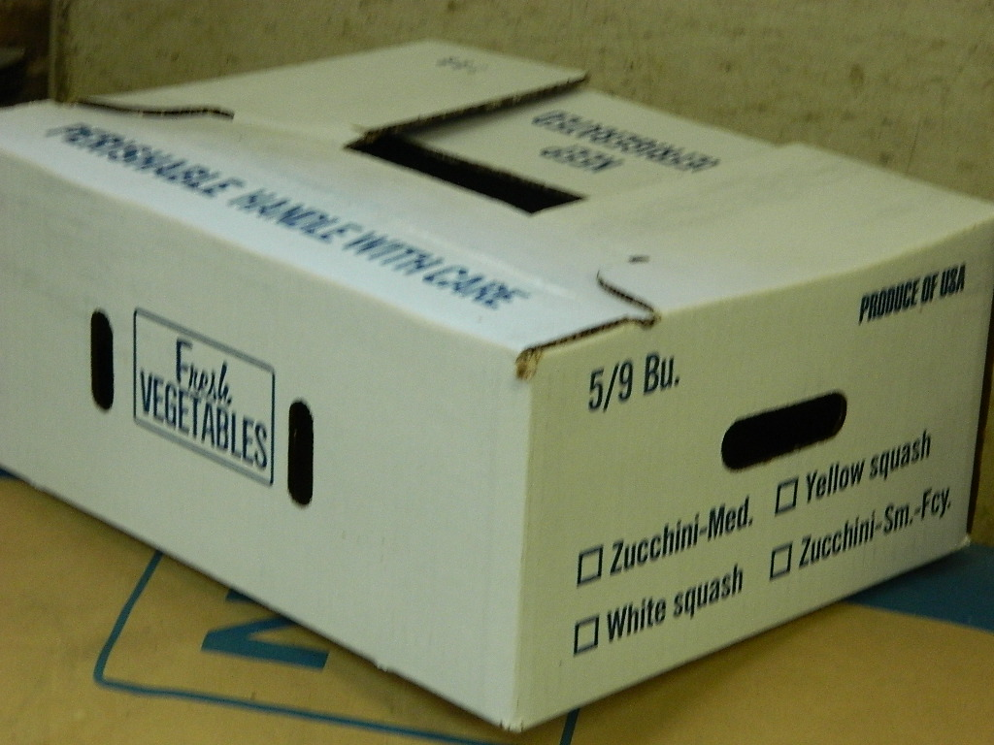
If you bought a Couple or Every-Other-Week Couple Share, you'll pick up this box, a 5/9 bushel. Short, squat, white, light blue lettering.

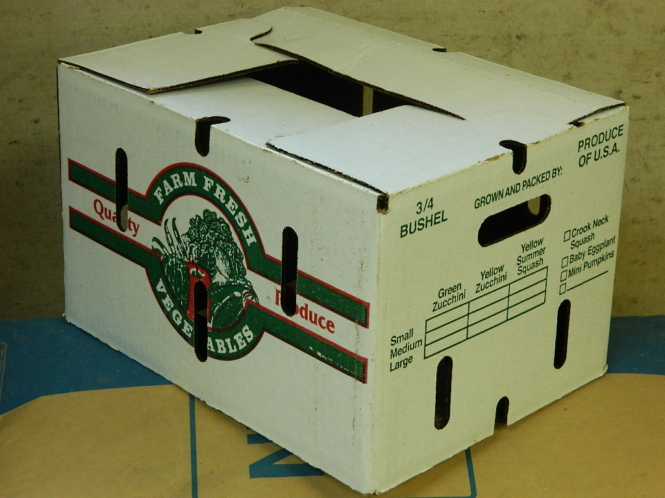
If you bought a Family Share, you get this box, a ¾ bushel. Tall, colorful, with red, white and green lettering.

If you forget what you signed up for, the size Share is next to your name on the signin sheet.
If you can not or do not get your box on Wednesday, we will automatically hang onto it for 24 hours from the close of our site. Call, text or email us ASAP to arrange retrieval.
One last reminder: unfold your CSA box before you leave it behind in our barn.
Here's the link to watch a short YouTube video on how to unfold a wax box:
http://www.youtube.com/watch?v=IEaBFTlnGdo

I do a lot of communicating with you by email. Newsletters, announcements, special information all go out by email. The Farmigo CSA software makes this very easy to do. Texting is not an efficient option with 30 CSA members. If you are not in the habit of checking your email every day, please try to do so several times a week so you read everything I send you. I promise, everything I send will be about our CSA program.
And finally:

Have a wonderful
4th of July!!!

Terry & Chuck

